**E-PROJECT**

**LABAUTOMATION**

**WEBSITE**

**DOCUMENTATION**

**PROJECT GROUP MEMBERS**

|  |  |
| --- | --- |
| **STUDENT ID** | **STUDENT NAME** |
| Student:1294952 | AASIA |
| Student:1316986 | SAMRA JAVAID KHAN |
| Student: 1276643 | MUHAMMAD HAMZA |
| Student:1305911 | RAZI SIDDIQUE |

**CURRICULUM:**

**OV-ACCP Prime-6740-ACE**

**BATCH:**

**2104B1**

**FACULTY:**

**Miss Muniba Javaid**

**CO-ORDINATOR:**

**Miss Areeba**

**INSTITUTE:**

**Aptech North Nazimabad**

**ACKNOWLEDGEMENT**

To start with, By the Grace of Almighty Allah we are completed some phases of our project to demonstrate.

We are grateful to the project supervisor Miss Muniba Javaid for her overseen throughout the project time. She helped us a lot by sharing her valuable expertise with us.

Moreover, we would like to thank and courtesy to the e-Project team at Aptech Head Office, who give a Golden chance to accomplish this astonishing project about Lab Automation.

At last, WE owe our deep gratitude to our project guide Ms. Muniba Javaid, who took keen interest on our project work and guided us all along, till the completion of our project work by providing all the necessary information for developing a good system.

**ABSTRACT**

This project is aimed at developing a Lab Automation for the facilities in the campus. The software industry continues to evolve rapidly, expanding due to innovative products and services application. Software Industry consist of software development, designing and testing.

Lab Automation are involved in the creation and make a resistor, switches, gears, electrical circuit, capacitors and so on.

There are many stages like testing a product. This report is intended to give a complete overview of our project **“THE** **ELECTRICAL LAB AUTOMATION”** including the software requirements specification working tools, features, analysis model and overall description therein.

There are a set of guidelines to be followed while preparing the software requirement specification document. This includes the purpose, scope, functional and non-functional requirements, software, and hardware requirements of the project.

In addition to this, it also contains the information about environmental conditions required, safety and security requirements, software quality attributes of the project etc.

**TABLE OF CONTENT:**

**1.Introduction:**

1.1 Purpose

1.2 Problem Introduction

1.3 Modules

**2.Requirments:**

2.1 Functional Requirements

2.2 Project Scope

**3.Requirment Specification:**

3.1 Introduction

3.2 Hardware Requirements

3.3 Hardware Requirements for Present Project

3.4 Software Requirements

3.5 Software Requirements for Present Project

**4.Analysis:**

4.1 Proposed System

4.2 Feasibility Study

4.3 Economic Feasibility

4.4 Technical Feasibility

4.5 Operational Feasibility

4.6 language Specification

**5.Design:**

5.1 Systematic Design

**6.Testing:**

6.1 System Testing

6.2 Types of Testing

**7.Snapshots:**

7.1 Screen shots

**8.TaskSheet:**

8.1 Task 1

8.2 Task 2

8.3 Task 3

8.4 Submission

**9.Conclusion:**

9.1 Ending of Project

**SERIES :1**

**INTRODUCTION**

**1.1 Purpose**

Automation **reduces time, effort and cost, whilst reducing manual errors, giving your business more time to focus on your primary objectives**. Repetitive tasks can be completed faster. Automating processes ensures high quality results as each task is performed identically, without human error The SRS documents details all features upon which we have currently decided with references to the manner and importance of their implementation.

**1.2 problem statement**

Problem statement is attached separately in a file “**Lab Automation**”

**Standards plan:**

Every code block must have comments.

The logic of the program needs to be explained. Proper documentation should be maintained.

Complete Project Report along with synopsis, code and documentation should be prepared.

**Documentation:**

No project is complete without documentation. In fact, it is one of the most important activities during the development of a project. The documentation of an ideal project will be in the form of a project report comprising of the following documents:

* Table of Contents.
* Problem Definition.
* Customer Requirement Specification.
* Project Plan.
* E-R Diagrams.
* Algorithms.
* GUI Standards Document.
* Interface Design Document.
* Task Sheet.
* Project Review and Monitoring Report.
* Unit Testing Check List.
* Final Check List.

1.3 **Modules**

The entire project mainly consists of 3 modules, which are

* Admin
* Company
* Laboratory

**Admin Module:**

1. New User (Add / Update / Delete / View over all report)
2. Create Facilities (Add / Update / Delete / View over all report)

**\*NOTE**

Admin panel have all rights to access all area of The Electrical Lab Automation.

Admin panel give authorities to staff and public users.

**Company Module:**

1. Check Status(add/update/delete)

**Laboratory Module:**

1. Testing Products

**SERIES :2**

**REQUIREMENTS**

* 1. **Functional Requirements**
* The admin has the right to access all the pages of the website.
* The admin will only be able to access the details of the testing products where he can change, update the details.
* A Database to store all the details of the products hold and refused from either the customer or from the other branches
  1. **Project scope**

Lab automation refers to the process in which specimen processing equipment is utilized with the purpose of **performing testing products and working on research**. This process is carried out to develop new technology, for improving products quality and declining the time cycles.

The role of automation is **to take care of the tasks that machines can do better than us, removing human error and allowing for scalability**. One common misconception about automation is that it's a set-it-and-forget-it approach.

Automation is a rapidly evolving field and currently **there is a tremendous scope and job opportunities available in the market for Automation electrical Engineers**.

Automation testing holds a very bright future. Even though the automation tools will build the test cases and code tests, the output of these tools still needs to be validated. Thus, the era of evolution and growth will continue in years to come.

**SERIES :3**

**REQUIREMENTS SPECIFICATION**

3.1 **introduction**

To be used efficiently, all computer software needs certain hardware components or the other software resources to be present on a computer. These pre-requisites are known as (computer) system requirements and are often used as a guideline as opposed to an absolute rule. Most software defines two sets of system requirements: minimum and recommended. With increasing demand for higher processing power and resources in newer versions of software, system requirements tend to increase over time. Industry analysts suggest that this trend plays a bigger part in driving upgrades to existing computer systems than technological advancements.

3.2 **hardware requirements**

The most common set of requirements defined by any operating system or software application is the physical computer resources, also known as hardware. A hardware requirements list is often accompanied by a hardware compatibility list (HCL), especially in case of operating systems. An HCL lists tested, compatibility and sometimes incompatible hardware devices for particular operating system or application. The following sub-sections discuss the various aspects of hardware requirements.

3.3 **hardware requirements for present project**

PROCESSOR: Intel dual Core, i5

RAM: 4 GB

HARD DISK: 250 GB

3.4 **Software requirements**

Software Requirements deal with defining software resource requirements and pre-requisites that need to be installed on a computer to provide optimal functioning of an application. These requirements or pre-requisites are generally not included in the software installation package and need to be installed separately before the software is installed.

3.5 **Software requirements for present project**

OPERATING SYSTEM: Windows 7/ XP/8/10

SOFTWARE: Visual Studio 2013/2017

FRONT END: Html, CSS, Bootstrap, JavaScript J-Query,PHP

DATABASE: SQL Server

**SERIES :4**

**ANALYSIS**

4.1 **Proposed System**

Proposal automation is **the use of technology to perform actions in the proposal process with no human intervention**. Essentially, it takes simple, repetitive tasks and sets rules that enable technology to complete those tasks at the right time, in the right way, automatically

4.2 **Feasibility Study**

The feasibility of the project is analyzed in this phase and business proposal is put forth with a very general plan for the project and some cost estimates. During system analysis the feasibility study of the proposed system is to be carried out. This is to ensure that the proposed system is not a burden to the company. For feasibility analysis, some understanding of the major requirements for the system is essential.

Three key considerations involved in the feasibility analysis are:

4.3 **Economic Feasibility**

This study is carried out to check the economic impact will have on the system will have on the organization. The amount of fund that the company can pour into the research and development of the system is limited. The expenditures must be justified. Thus, the developed system as well within the budget and this was achieved because most of the technologies used are freely available. Only the customized products have to be purchased.

4.4 **Operational Feasibility**

The aspect of study is to check the level of acceptance of the system by the user. This includes the process of training the user to use the system efficiently. The user must not feel threatened by the system, instead must accept it as a necessity. The level of acceptance by the users solely depends on the methods that are employed to educate the user about the system and to make him familiar with it. His level of confidence must be raised so that he is also able to make some constructive criticism, which is welcomed, as he is the final user of the system.

4.5 **Technical Feasibility**

This study is carried out to check the technical feasibility, that is, the technical requirements of the system. Any system developed must not have a high demand on the available technical resources. This will lead to high demands being placed on the client. The developed system must have a modest requirement, as only minimal or null changes for the implementing this system.

4.6 **Languages**

4.6.1 **Html:**

HTML is a markup language that defines the structure of your content. HTML consists of a series of elements, which you use to enclose, or wrap, different parts of the content to make it appear a certain way or act a certain way. The enclosing tags can make a word or image hyperlink to somewhere else, can italicize words, can make the font bigger or smaller, and so on.

The main parts of our element are as follows:

1. **The opening tag:** This consists of the name of the element (in this case, p), wrapped in opening and closing angle brackets. This states where the element begins or starts to take effect — in this case where the paragraph begins.
2. **The closing tag:** This is the same as the opening tag, except that it includes a forward slash before the element name. This states where the element ends — in this case where the paragraph ends. Failing to add a closing tag is one of the standard beginner errors and can lead to strange results.
3. **The content:** This is the content of the element, which in this case, is just text.
4. **The element:** The opening tag, the closing tag, and the content together comprise the element.

4.6.2 **CSS:**

CSS Stands for "Cascading Style Sheet." Cascading style sheets are used to format the layout of web pages. They can be used to define text styles, table sizes, and other aspects of Web pages that previously could only be defined in a page's HTML.

CSS helps Web developers create a uniform look across several pages of a Web site. Instead of defining the style of each table and each block of text within a page's HTML, commonly used styles need to be defined only once in a CSS document. Once the style is defined in cascading style sheet, it can be used by any page that references the CSS file. Plus, CSS makes it easy to change styles across several pages at once. For example, a Web developer may want to increase the default text size from 10pt to 12pt for fifty pages of a Web site. If the pages all reference the same style sheet, the text size only needs to be changed on the style sheet and all the pages will show the larger text.

While CSS is great for creating text styles, it is helpful for formatting other aspects of Web page layout as well. For example, CSS can be used to define the cell padding of table cells, the style, thickness, and colour of a table's border, and the padding around images or other objects. CSS gives Web developers more exact control over how Web pages will look than HTML does. Therefore most Web pages today incorporate cascading style sheets.

4.6.3 **bootstrap:**

Bootstrap is a free open source front end development framework for the creation of websites and web apps. Designed to enable responsive development of mobile first websites, Bootstrap provides a collection of syntax for template designs.

As a framework, Bootstrap includes the basics for responsive web development, so developers only need to insert the code into a pre-defined grid system. The bootstrap framework is built on Hypertext Markup Language (HTML), cascading style sheets (CSS) and Javascript. Web developers using Bootstrap can build websites much faster without spending time worrying about basic commands and functions

Bootstrap makes responsive web design a reality. It makes it possible for a web page or app to detect the visitor's screen size and orientation and automatically adapt the display accordingly. The mobile-first approach assumes smartphone,tablets and task-specific mobile apps are employees' primary tools for getting work done. Bootstrap addresses the requirements of those technologies in design includes UI components, layouts, JavaScript tools and the implementation framework. The software is available precompiled or as source code.

4.6.4 **J-Query:**

J-Query is an open-sourced JavaScript library that simplifies creation and navigation of web applications. Specifically, jQuery simplifies HTML Document Object Model (DOM) manipulation, Asynchronous JavaScript and XML ([Ajax](https://theserverside.techtarget.com/definition/Ajax)) and event handling. Additionally, jQuery incorporates JavaScript functionalities by manipulating CSS properties to add effects such as fade-ins and outs for website elements. jQuery is a widely used JavaScript library and is supported by thousands of user-created plugins.

jQuery will simplify DOM manipulation by allowing users to find, select and manipulate elements with specific properties. Users can also change element attributes and respond to events. jQuery can use Ajax to pass data between browsers and the servers without having to reload the web page. Event handling is provided by an event handler which receives an object upon an event. The event handler specifies the type of event and executes a DOM element function to prevent the event’s effect. The syntax for these simplicities is provided through jQuery’s selector engine, Sizzle. Sizzle is a CSS selector engine which can run through DOM elements to find specified elements.

4.6.5 **Javascript:**

JavaScript is a text-based programming language used both on the client-side and server-side that allows you to make web pages interactive. Where HTML and CSS are languages that give structure and style to web pages, JavaScript gives web pages interactive elements that engage a user. Common examples of JavaScript that you might use every day include the search box on Amazon, a news recap video embedded on The New York Times, or refreshing your Twitter feed.

Incorporating JavaScript improves the user experience of the web page by converting it from a static page into an interactive one. To recap, JavaScript adds behaviour to web pages

JavaScript is mainly used for web-based applications and web browsers. But JavaScript is also used beyond the Web in software, servers and embedded hardware controls. Here are some basic things JavaScript is used for:

      Adding interactive behaviours to web pages

JavaScript allows users to interact with web pages. There are almost no limits to the things you can do with JavaScript on a web page – these are just a few examples:

* Show or hide more information with the click of a button
* Change the colour of a button when the mouse hovers over it
* Slide through a carousel of images on the homepage
* Zooming in or zooming out on an image
* Displaying a timer or count-down on a website
* Playing audio and video in a web page
* Displaying animations

4.6.5 **PHP:**

PHP is a script language and interpreter that is freely available and used primarily on Linux Web servers. PHP, originally derived from Personal Home Page Tools, now stands for PHP: HypertextPreprocessor, which the PHP FAQ describes as a "recursive acronym."

PHP executes on the server, while a comparable alternative, JavaScript, executes on the client. PHP is an alternative to Microsoft's Active Server Page (ASP) technology. As with ASP, the PHP script is embedded within a Web page along with its HTML. Before the page is sent to a user that has requested it, the Web server calls PHP to interpret and perform the operations called for in the PHP script.

An HTML page that includes a PHP script is typically given a file name suffix of ".PHP" ".php7," or ".PHTML. Like ASP, PHP can be thought of as "dynamic HTML pages," since content will vary based on the results of interpreting the script.

**SERIES :5**

**DESIGN**

**SYSTEM DESIGN:**

**INTRODUCTION TO UML:**

**UML Design:**

The Unified Modelling Language (UML) is a standard language for specifying, visualizing, constructing, and documenting the software system and its components. It is a graphical language, which provides a vocabulary and set of semantics and rules. The UML focuses on the conceptual and physical representation of the system. It captures the decisions and understandings about systems that must be constructed. It is used to understand, design, configure, maintain, and control information about the systems.

The UML is a language for:

* Visualizing
* Specifying
* Constructing
* Documenting

**Visualizing:**

Through UML we see or visualize an existing system and ultimately, we visualize how the system is going to be after implementation. Unless we think, we cannot implement. UML helps to visualize, how the components of the system communicate and interact with each other.

**Specifying:**

Specifying means building, models that are precise, unambiguous and complete UML addresses the specification of all the important analysis design, implementation decisions that must be made in developing and deploying a software system.

**Constructing:**

UML models can be directly connected to a variety of programming language through mapping a model from UML to a programming language like HTML, CSS, BOOTSTRAP. Forward Engineering and Reverse Engineering is possible through UML.

**Documenting:**

The Deliverables of a project apart from coding are some Artifacts, which are critical in controlling, measuring and communicating about a system during its developing requirements, architecture, desire, source code, project plans, tests, prototypes releasers, etc.

**UML Approach**

**UML Diagram:**

A diagram is the graphical presentation of a set of elements, most often rendered as a connected graph of vertices and arcs. You draw diagram to visualize a system from different perspective, so a diagram is a projection into a system. For all but most trivial systems, a diagram represents an elided view of the elements that make up a system. The same element may appear in all diagrams, only a few diagrams, or in no diagrams at all. In theory, a diagram may contain any combination of things and relationships. In practice, however, a small number of common combinations arise, which are consistent with the five most useful views that comprise the architecture of a software-intensive system. For this reason, the UML includes nine such diagrams:

1. Class diagram

2. Object diagram

3. Use case diagram

4. Sequence diagram

5. Collaboration diagram

6. State chart diagram

7. Activity diagram

8. Component diagram

9. Deployment diagram

**USE CASE DIAGRAM:**

A use case diagram in the Unified Modelling Language (UML) is a type of behavioral diagram defined by and created from a use-case analysis. Its purpose is to present a graphical overview of the functionality provided by a system in terms of actors, their goals (represented as use cases), and any dependencies between those use cases. Use case diagrams are formally included in two modelling languages defined by the OMG: the undefined modelling language (UML) and the systems modelling language (SYSML).

**Use case diagram of our project:**

**FLOWCHART**

A flowchart is a type of diagram that represents a workflow or process. A flowchart can also be defined as a diagrammatic representation of an algorithm, a step-by- step approach to solving a task. The flowchart shows the steps as boxes of various kinds, and their order by connecting the boxes with arrows.

**Outer Design:**

Home

About Us

END

Login

Contact Us

Products

**LOGIN TO 3 DASHBOARDS:**



ADMIN DASHBOARD



COMPANY DASHBOARD





LABORATORY DASHBOARD

**ACTIVITY CHART:**

Activity diagrams are like flowcharts because they show the flow between the actions in an activity; however, activity diagrams can also show concurrent flows and alternate flows. In activity diagrams, you use activity nodes and activity edges to model the flow of control and data between actions.

Reject

Accept

Testing

Company Testing Form

View Test

Add Test

Testing

Testing

Products

Add Prod

View prod

View Tester

Add Tester

Add Tester

COMPANY

Products

ADMIN PANEL

LABORTORY

**ERD DIAGRAM:**

An Entity Relationship Diagram (ERD) is a snapshot of data structures. An Entity Relationship Diagram shows entities (tables) in a database and relationships between tables within that database. For a good database design, it is essential to have an Entity Relationship Diagram.

“There are three basic elements in ER-Diagrams.”

* Entities are the "things" for which we want to store information. An entity is a person, place, thing, or event.
* Attributes are the data we want to collect for an entity.
* Relationships describe the relations between the entities.

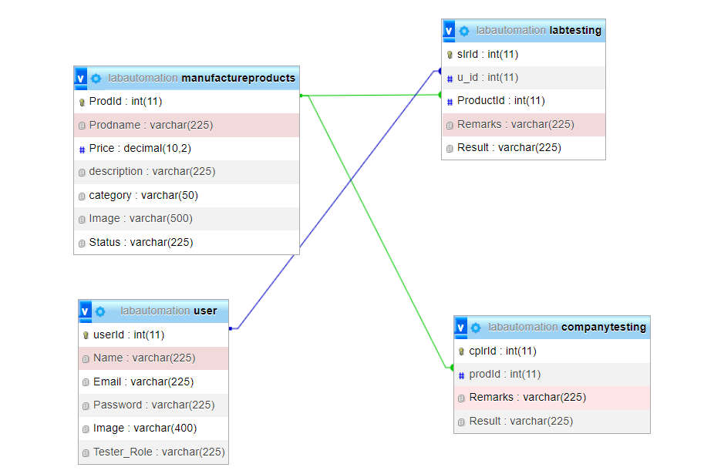

**SERIES 6:**

**TESTING**

6.1 **System Testing**

The purpose of testing is to discover errors. Testing is the process of trying to discover every conceivable fault or weakness in a work product. It provides a way to check the functionality of components, sub-assemblies, assemblies and/or a finished product It is the process of exercising software with the intent of ensuring that the Software system meets its requirements and user expectations and does not fail in an unacceptable manner. There are various types of tests. Each test type addresses a specific testing requirement.

Software testing is imperative, as it identifies any issue and defects with the written codes so they can be fixed before the software product is delivered. Improves products quality. When it comes to customer appeal, delivering a quality product is an important metric to consider.

**EXAMPLES FOR Systems Testing**

System testing verifies that an application performs tasks as designed. This step, a kind of black box testing, focuses on the functionality of an application. System testing, for example, might check that every kind of user input produces the intended output across the application

**Rules FOR Systems Testing**

* Testing should be based on the requirements of user.
* Before writing testing scripts, understand the business logic should be understood thoroughly.
* Test plan should be done as soon as possible.
* Testing should be done by the third party.
* It should be performed on static software.

**TYPES OF Systems Testing**

**6.2 Unit Testing:**

Unit testing involves the design of test cases that validate that the internal program logic is functioning properly, and that program inputs produce valid outputs. All decision branches and internal code flow should be validated. It is the testing of individual software units of the application .it is done after the completion of an individual unit before integration. This is a structural testing, that relies on knowledge of its construction and is invasive. Unit tests perform basic tests at component level and test a specific business process, application, and/or system configuration. Unit tests ensure that each unique path of a business process performs accurately to the documented specifications and contains clearly defined inputs and expected results.

**Integration testing:**

Integration tests are designed to test integrated software components to determine if they actually run as one program. Testing is event driven and is more concerned with the basic outcome of screens or fields. Integration tests demonstrate that although the components were individually satisfaction, as shown by successfully unit testing, the combination of components is correct and consistent. Integration testing is specifically aimed at exposing the problems that arise from the combination of components.

**Functional test:**

Functional tests provide systematic demonstrations that functions tested are available as specified by the business and technical requirements, system documentation, and user manuals.

Functional testing is centered on the following items:

Valid Input: identified classes of valid input must be accepted. Invalid

Input: identified classes of invalid input must be rejected. Functions

: identified functions must be exercised.

Output: identified classes of application outputs must be exercised.

Systems/Procedures: interfacing systems or procedures must be invoked. Organization and preparation of functional tests is focused on requirements, key functions, or special test cases. In addition, systematic coverage pertaining to identify Business process flows; data fields, predefined processes, and successive processes must be considered for testing. Before functional testing is complete, additional tests are identified and the effective value of current tests is determined.

**System Test:**

System testing ensures that the entire integrated software system meets requirements. It tests a configuration to ensure known and predictable results. An example of system testing is the configuration-oriented system integration test. System testing is based on process descriptions and flows, emphasizing pre-driven process links and integration points.

**White Box Testing:**

White Box Testing is a testing in which in which the software tester has knowledge of the inner workings, structure and language of the software, or at least its purpose. It is purpose. It is used to test areas that cannot be reached from a black box level.

**Unit Testing:**

Unit testing is usually conducted as part of a combined code and unit test phase of the software lifecycle, although it is not uncommon for coding and unit testing to be conducted as two distinct phases.

**Black Box Testing:**

Black Box Testing is testing the software without any knowledge of the inner workings, structure or language of the module being tested. Black box tests, as most other kinds of tests, must be written from a definitive source document, such as specification or requirements document, such as specification or requirements document. It is a testing in which the software under test is treated, as a black box. you cannot “see” into it. The test provides inputs and responds to outputs without considering how the software works.

**Test strategy and approach:**

Field testing will be performed manually, and functional tests will be written in detail.

**Test objectives**

* ➢ All field entries must work properly.
* ➢ Pages must be activated from the identified link.
* ➢ The entry screen, messages and responses must not be delayed.

**Features to be tested**

* Verify that the entries are of the correct format
* No duplicate entries should be allowed
* All links should take the user to the correct page.

**Integration Testing:**

Software integration testing is the incremental integration testing of two or more integrated software components on a single platform to produce failures caused by interface defects. The task of the integration test is to check that components or software applications, e.g., components in a software system or – one step up software applications at the company level – interact without error.

**Test Results:**

All the test cases mentioned above passed successfully. No defects encountered.

**SERIES 7:**

**SNAPSHOTS**

**HOME PAGE**

When user open our website, they will see this user- home page.

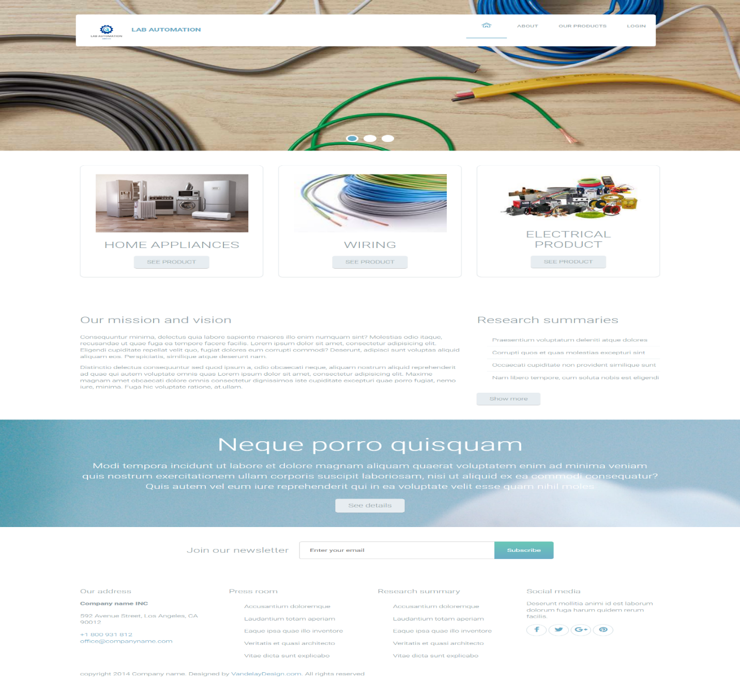

**ABOUT US**

At the same time user click on about us, they will see some 3 disparate section like details, about lab automation and testimonials.

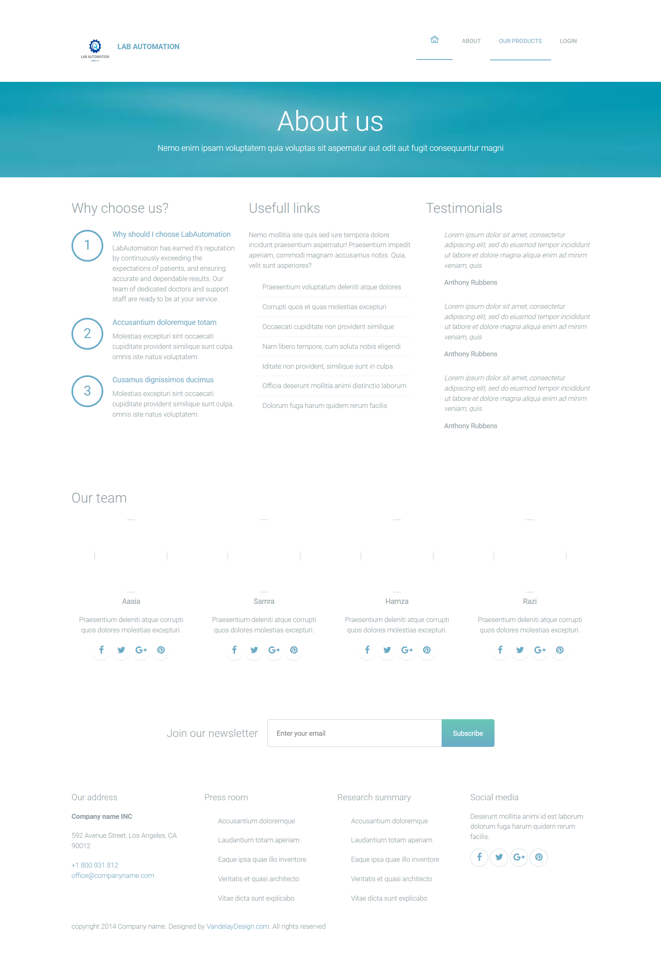

**PRODUCTS**

At the same time user click on product page anyone can access and see our products with their details

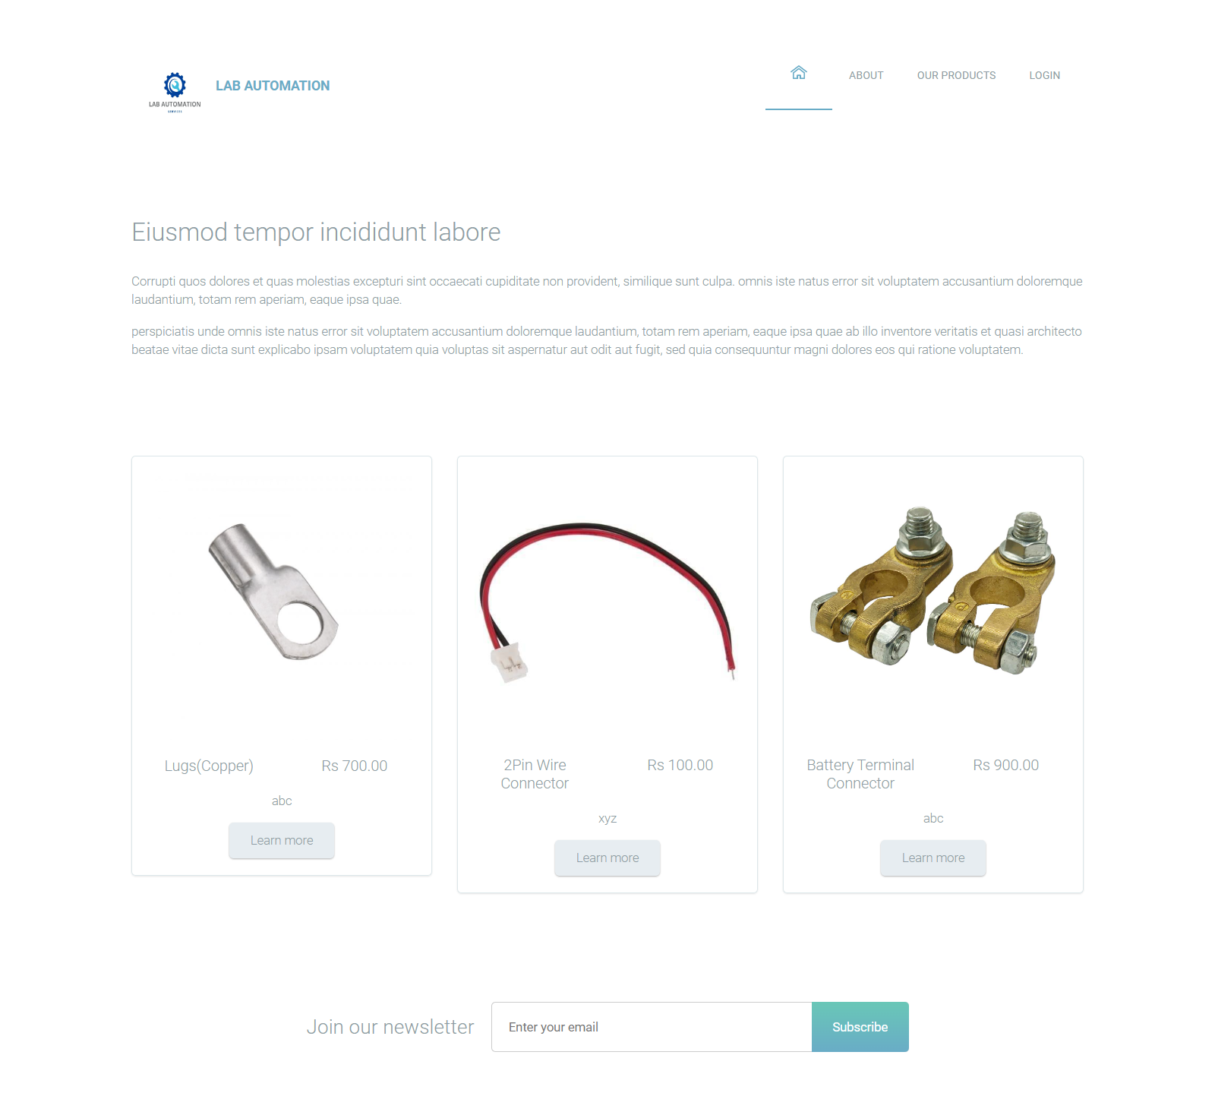

**LOGIN FORM**

In this curriculum we have three users firstly admin user secondly company user last but not the least laboratory user.

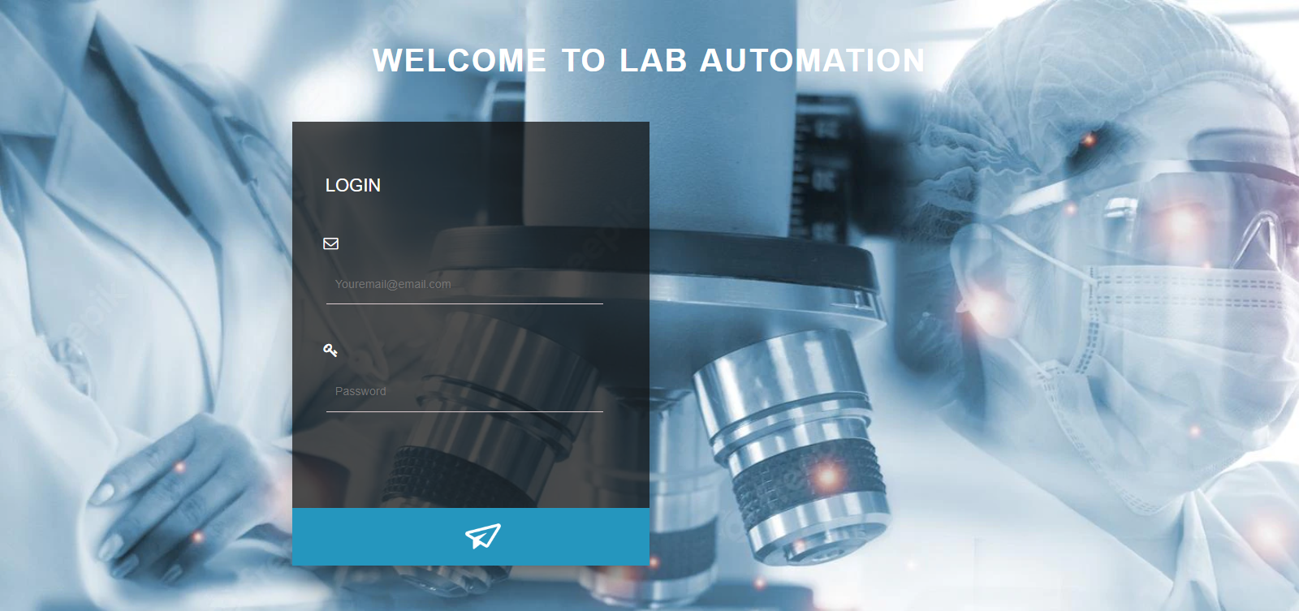

**ADMIN SITE**

**ADMIN LAYOUT**

When we login admin our website, they will see this admin

home page.

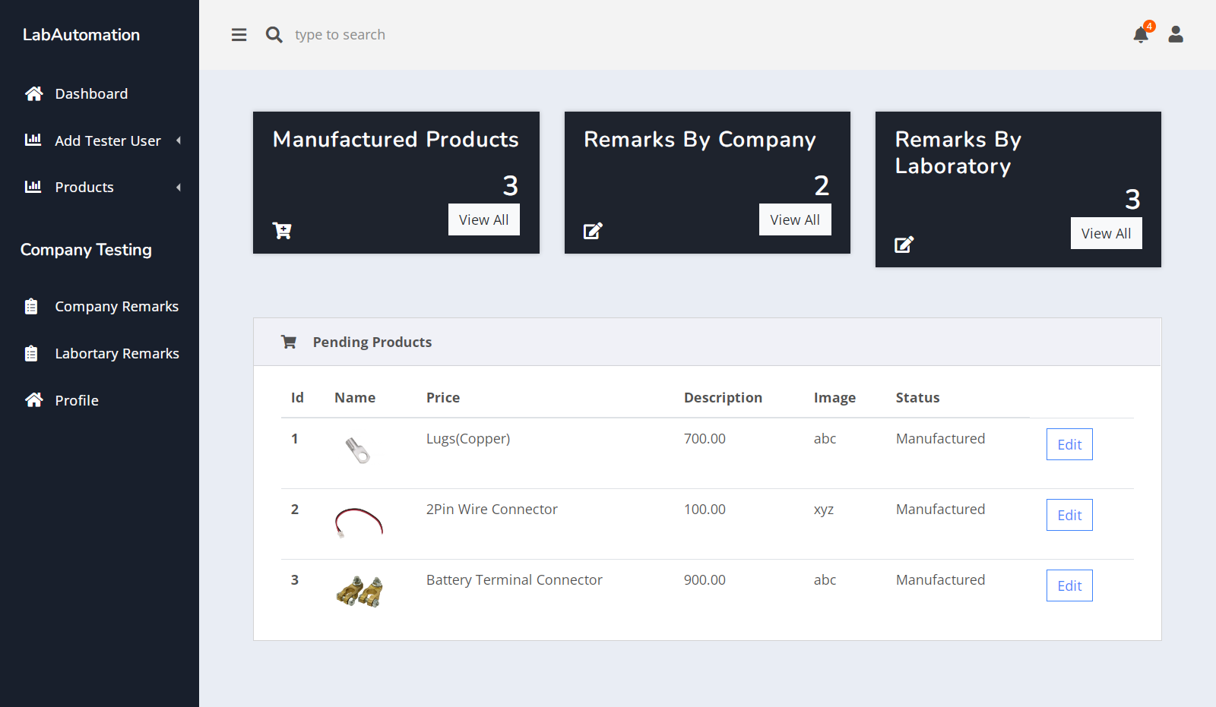

Add Tester:

In this page, how to add a user with the help of user tester add form.

* Fill-up a user add form
* All fields are mandatory
* Generate a password
* Form Submit

Now a user is successfully register in website.

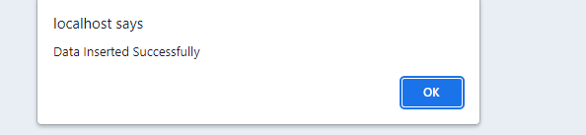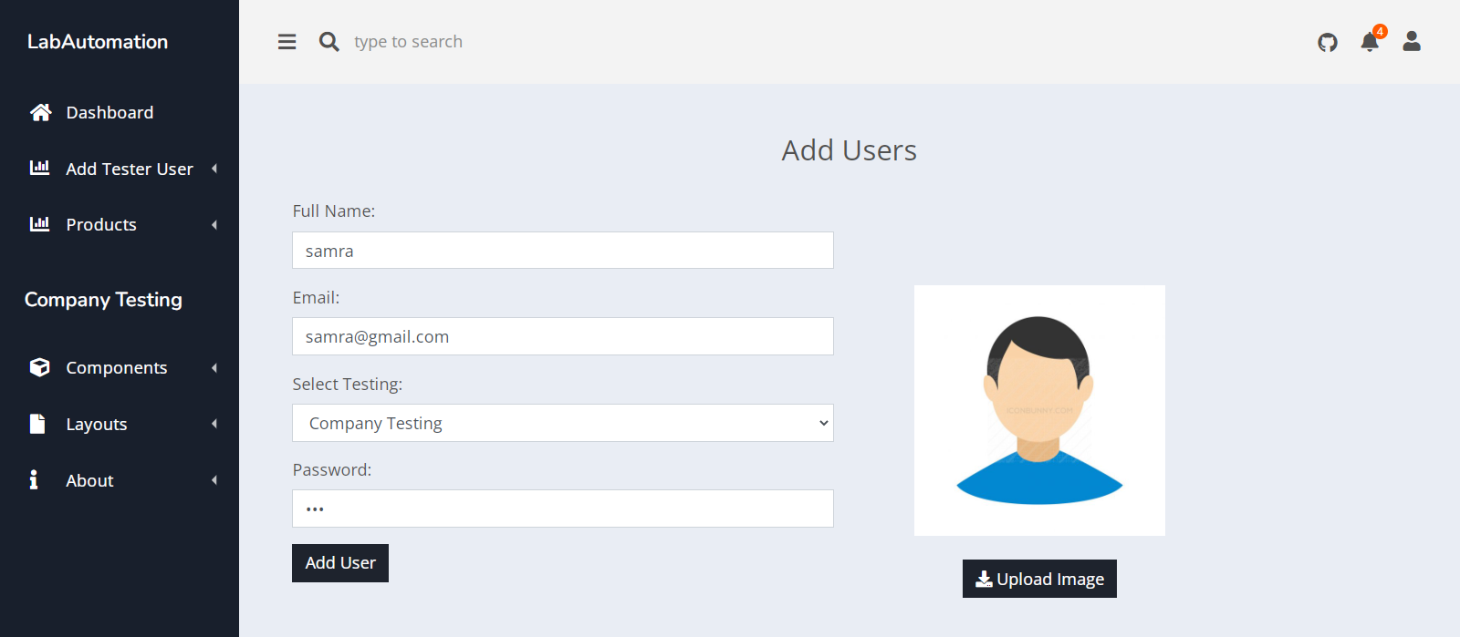

View-TESTER

In this page, we have shown an item what we are added tester users in view data tester users.

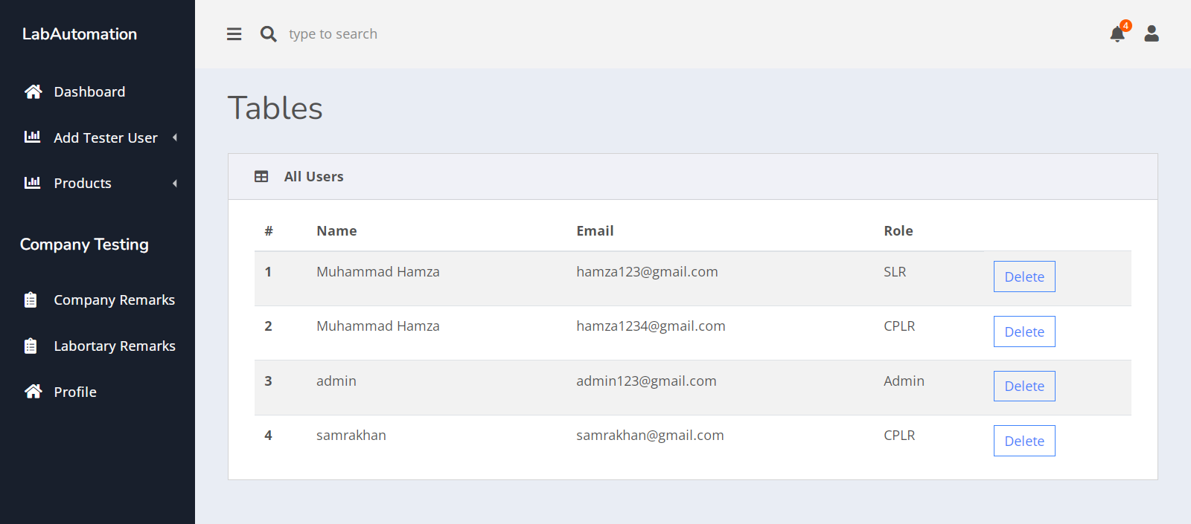

PRODUCTS

ADD PRODUCTS:

A user can add a product with the help of add product form.

User must fill-up all the requirements

* Product name
* Status
* Description
* Image
* Click on submit button

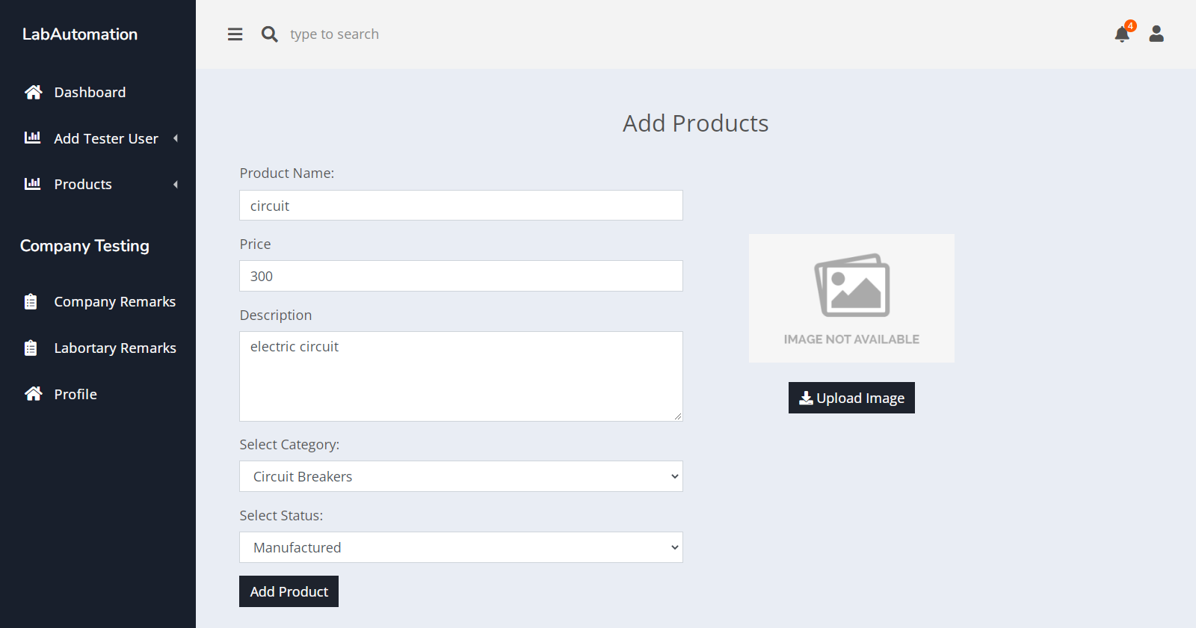

* Product is successfully added



COMPANY REMARKS:

Admin will see company remarks that the remarks will give the company.

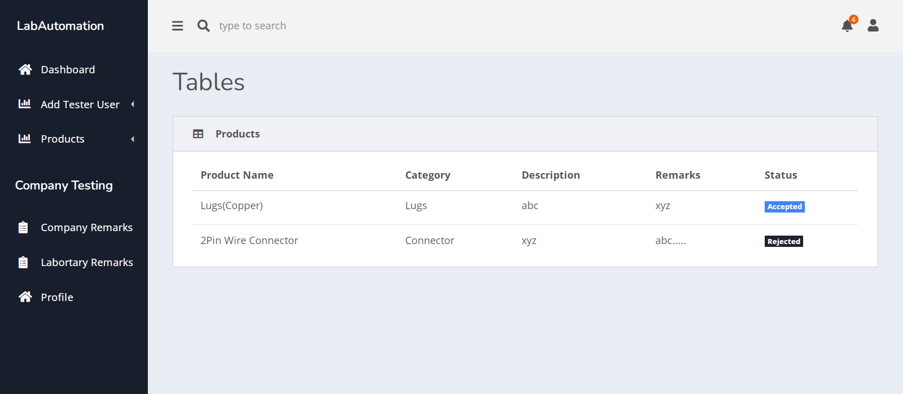

LABORATORY REMARKS:

Admin will see laboratory remarks that the remarks will give the laboratory.

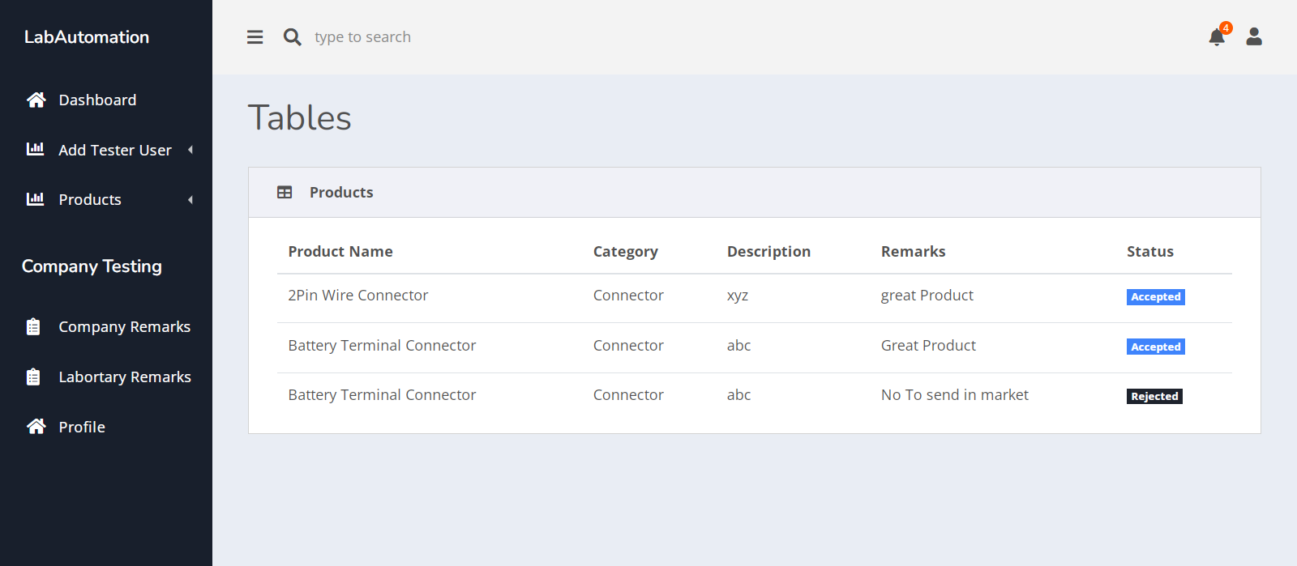

COMPANY SITE

PRODUCTS

TESTING-PRODUCTS

In this page we must focus on how company test the product. We have to show some of our products

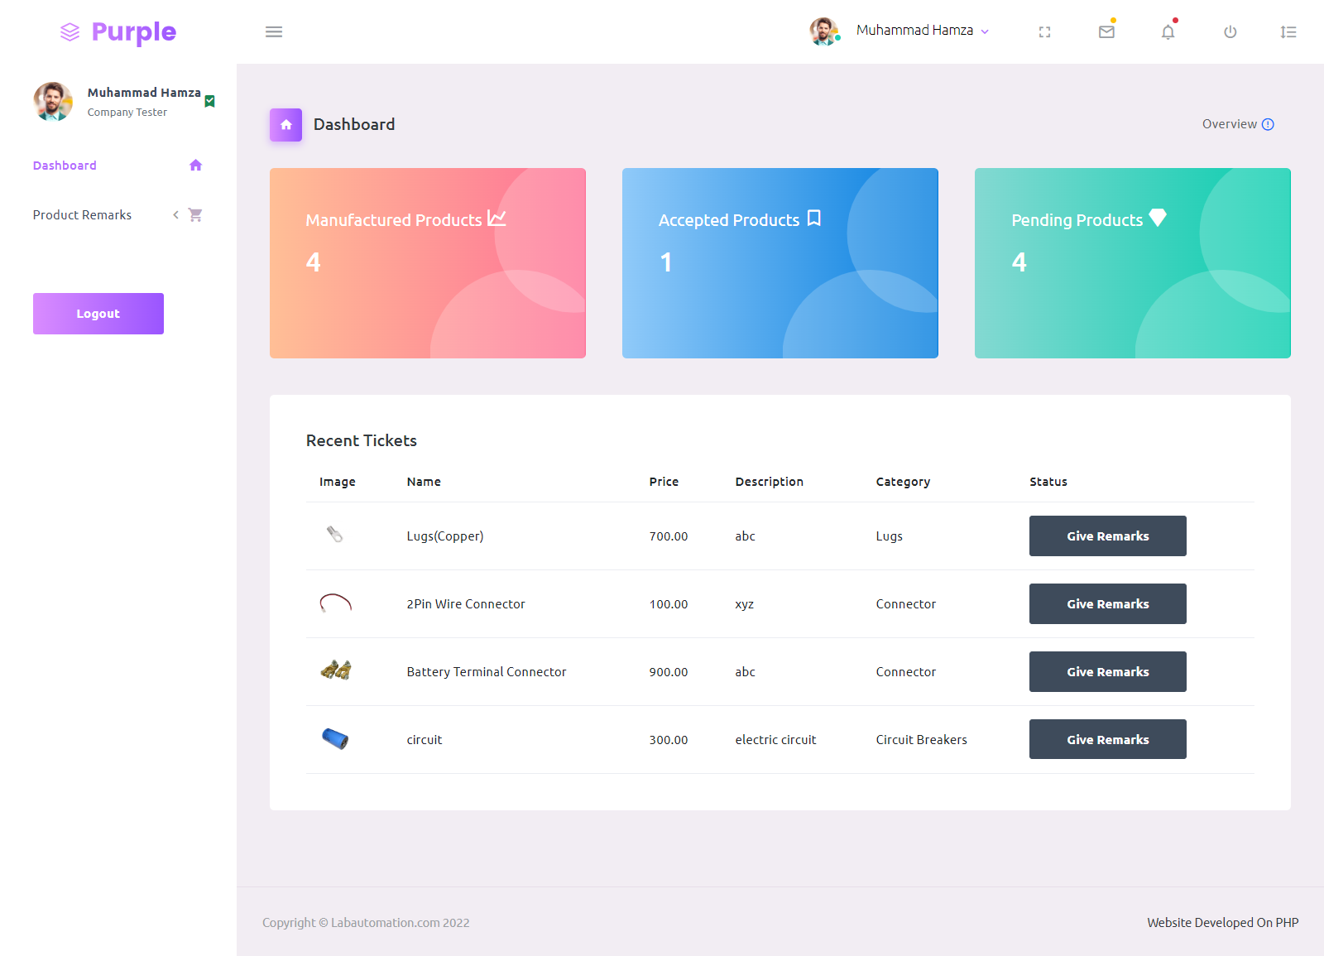

* If a company user clicks on give remarks, we have move to company tester form.
* Now fill-up the form.
* Submitted

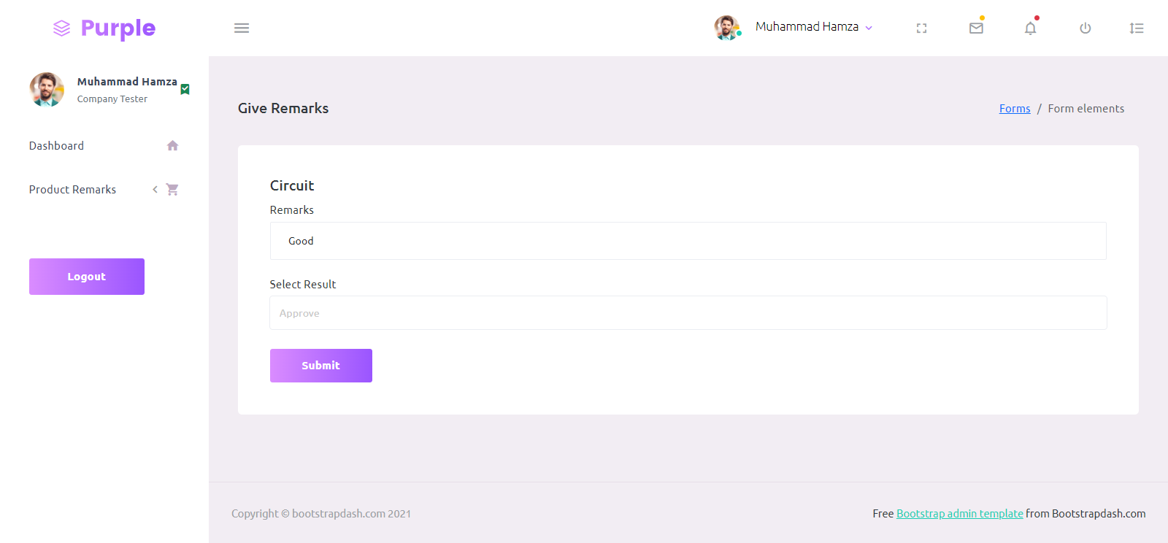

* If company tester approve the product the will show approved products as accepted list separately and also status will show accepted.

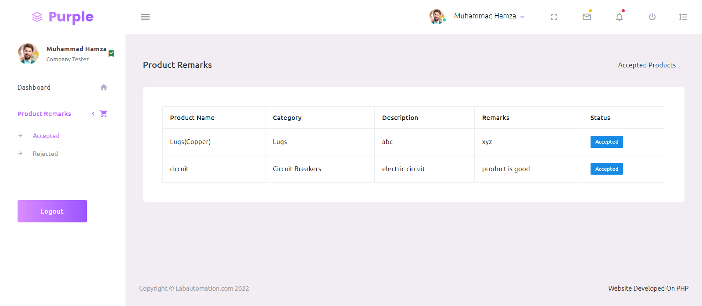

* If company tester reject the product the will show rejected products as rejected list separately and also status will show rejected.

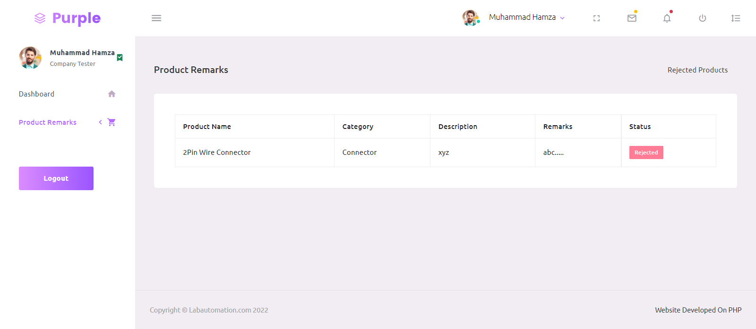

LABORATORY SITE

PRODUCTS

TESTING-PRODUCTS

In this page we must focus on how company test the product. We have to show some of our products

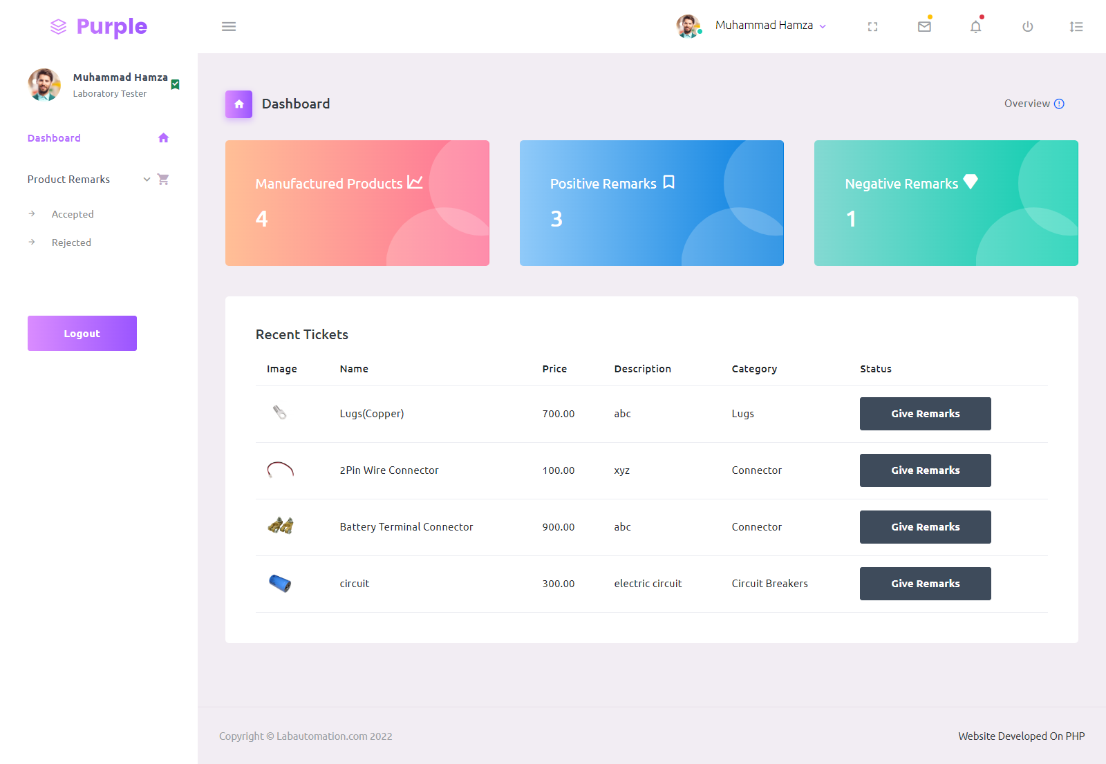

* If a company user clicks on give remarks, we have move to company tester form.
* Now fill-up the form.
* Submitted



* If laboratory tester approve the product the will show approved products as accepted list separately and also status will show accepted.



* If laboratory tester reject the product the will show rejected products as rejected list separately and also status will show rejected.



**SERIES :7**

**CODING SNAPSHOTS**

**ADMIN LAYOUT**

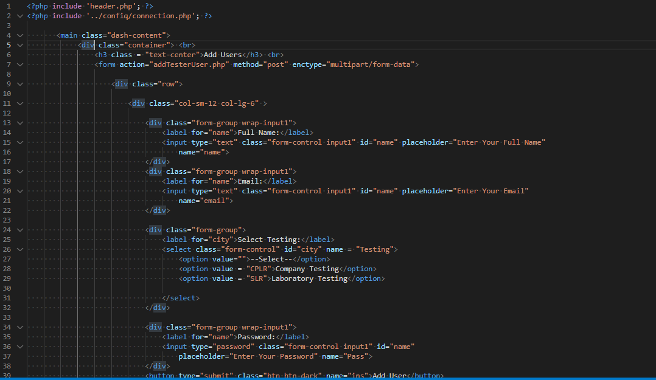

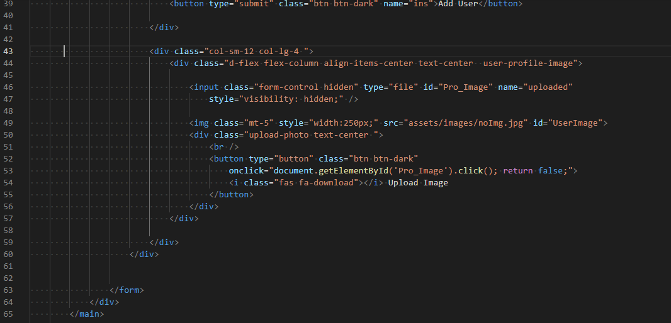

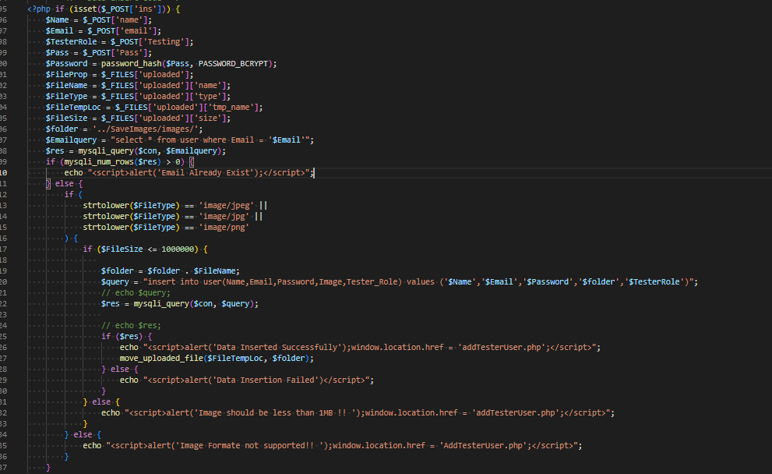

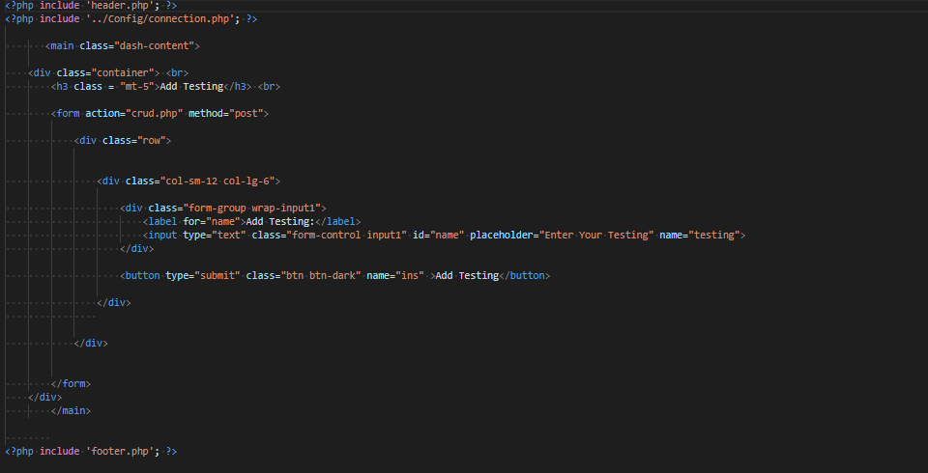

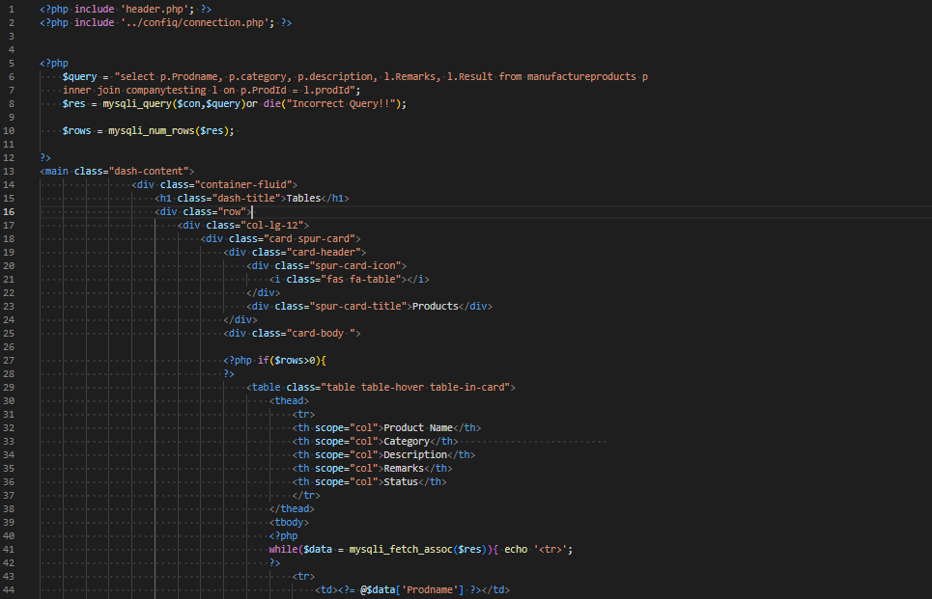

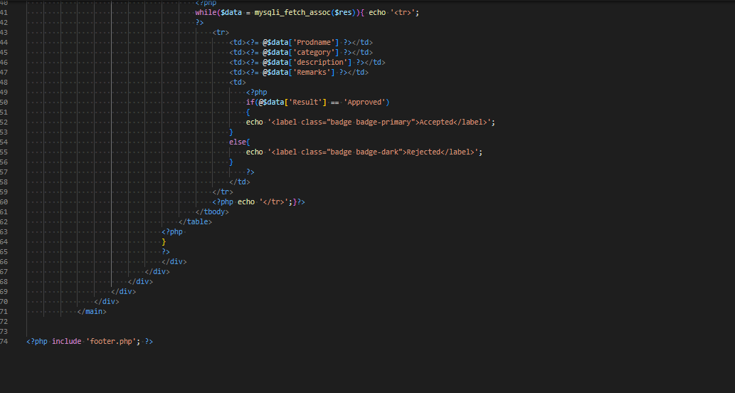

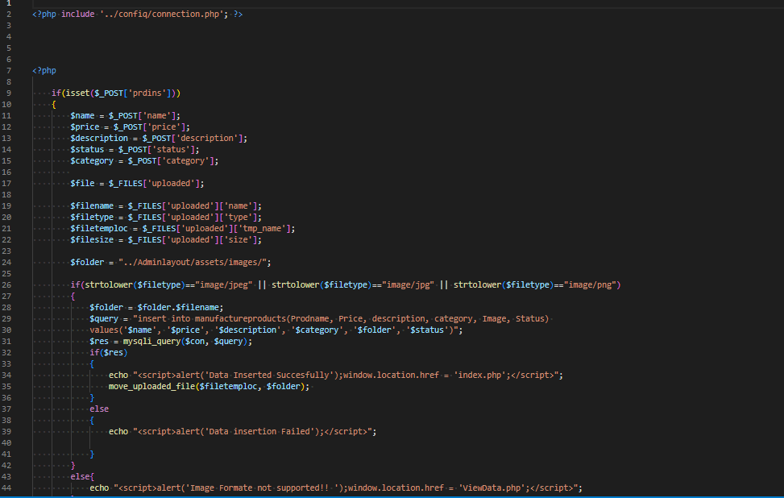

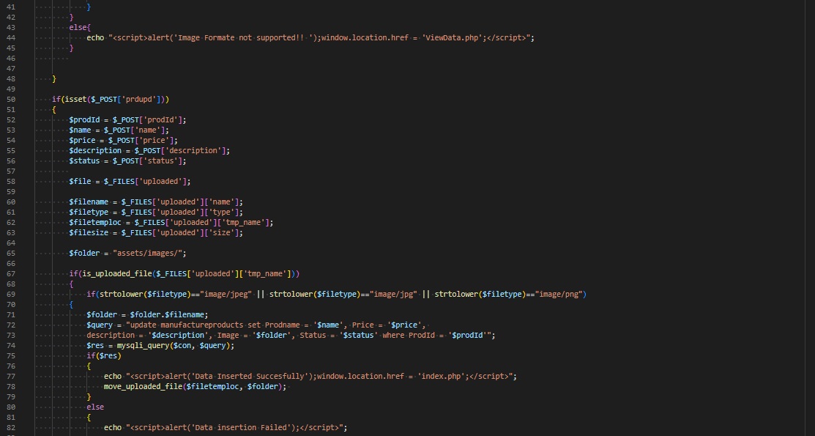

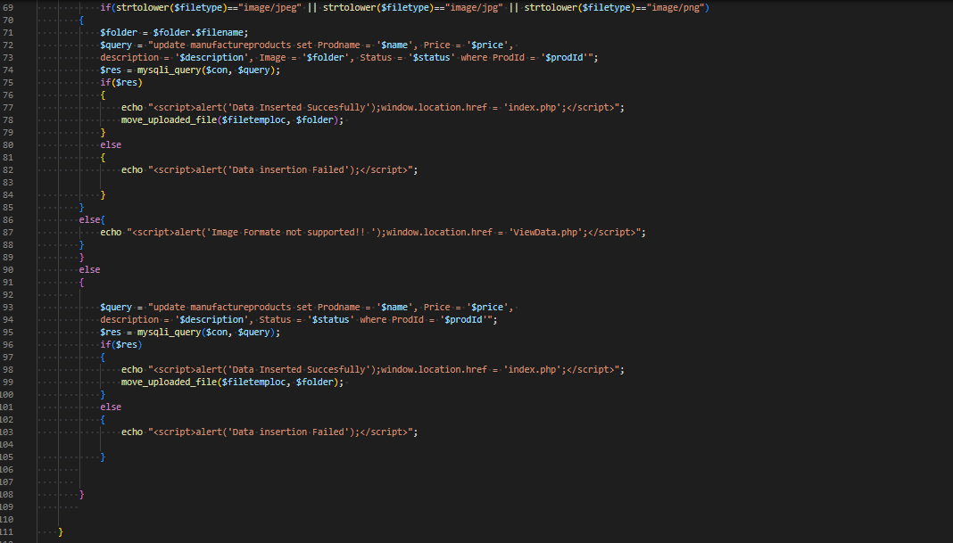

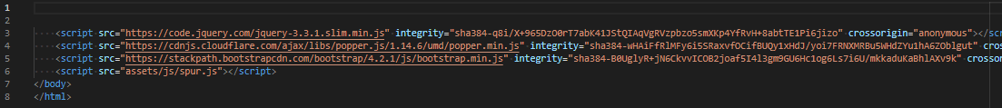

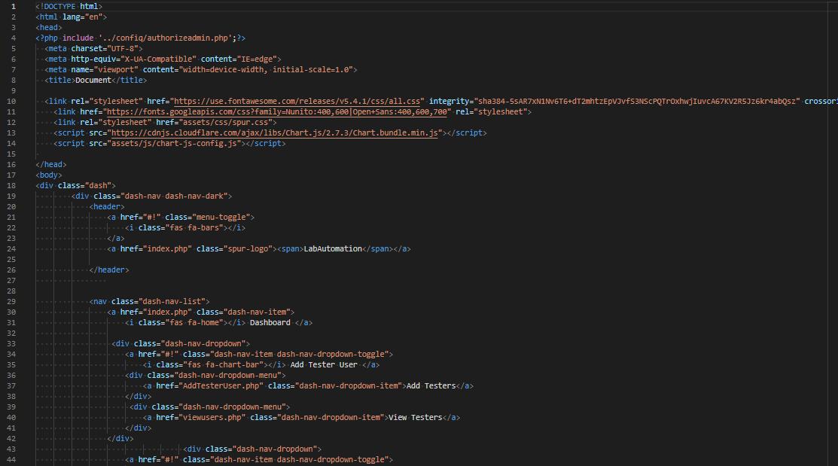

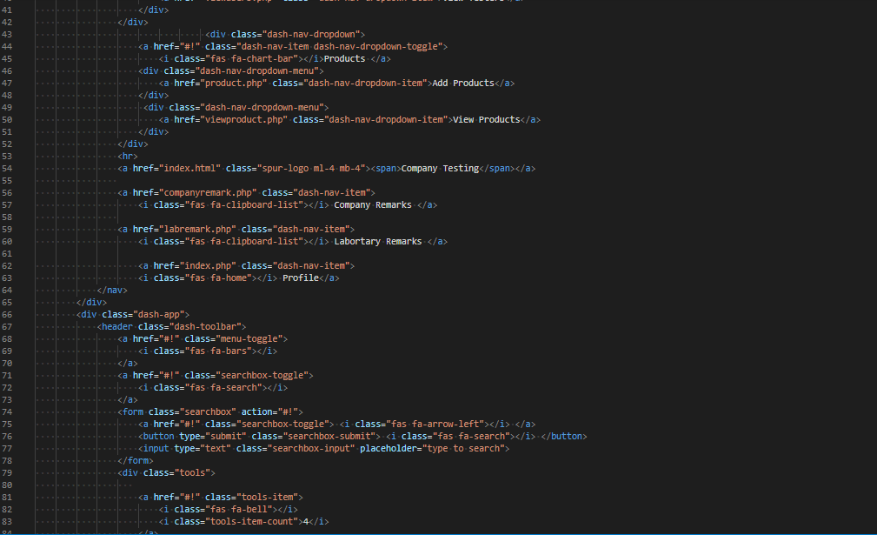

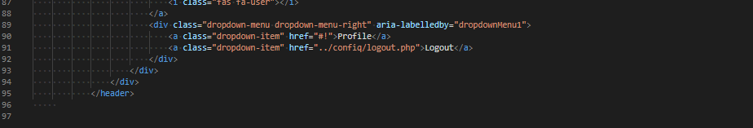

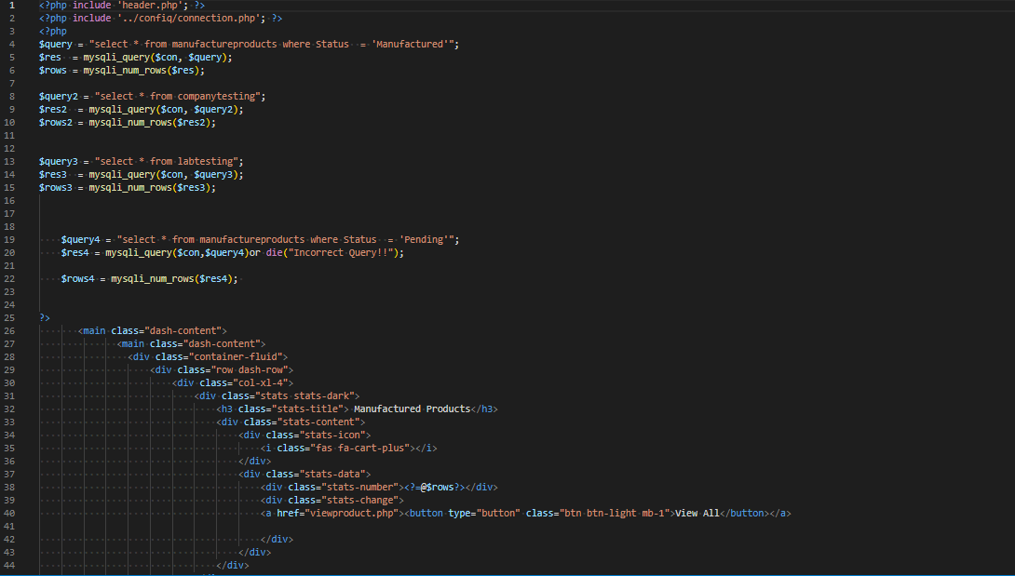

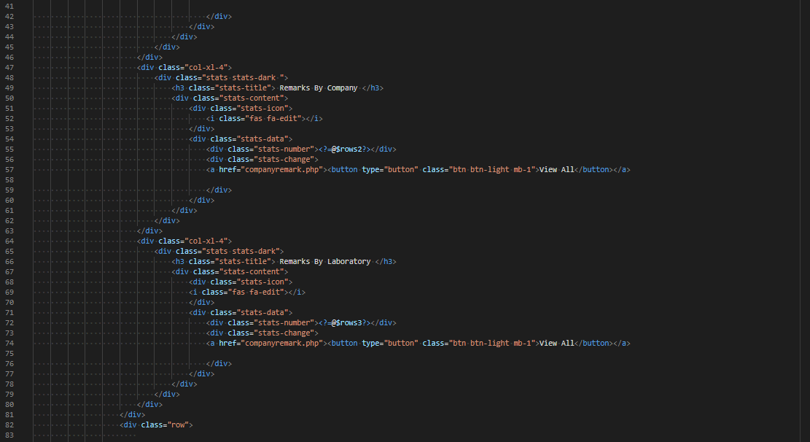

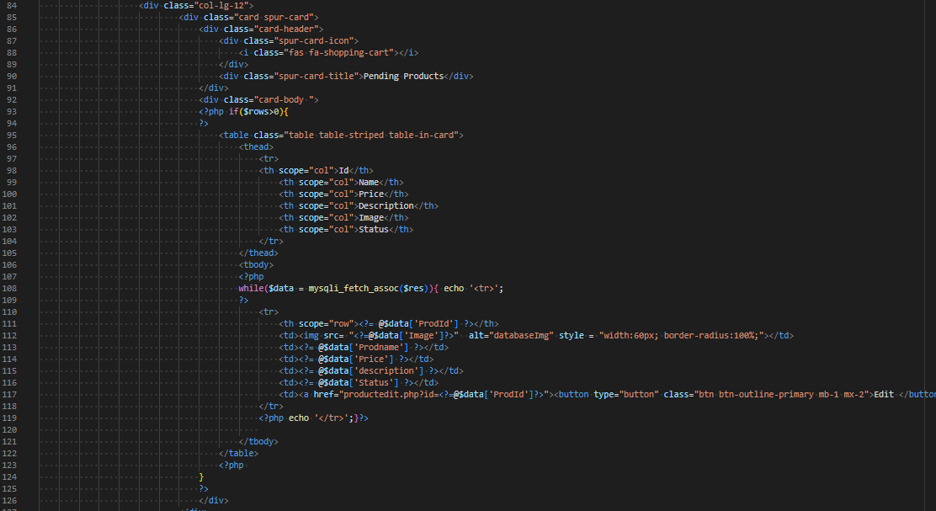

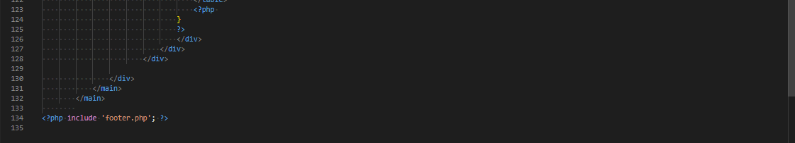

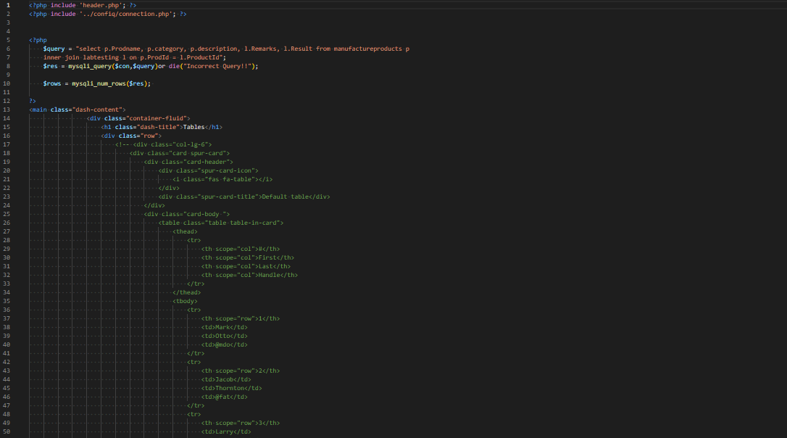

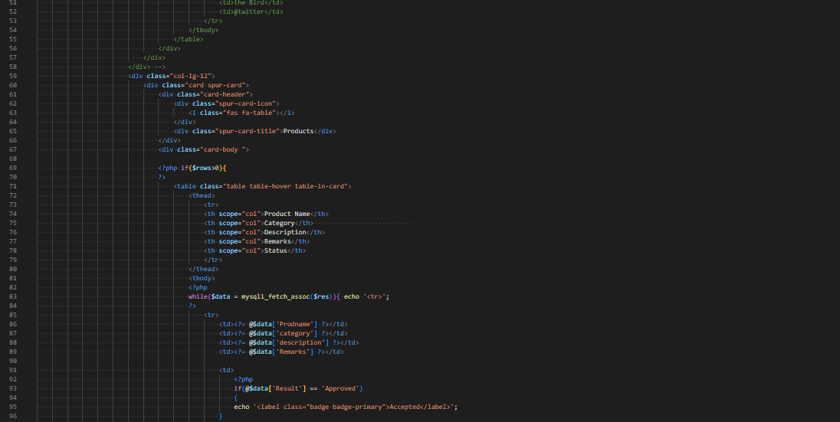

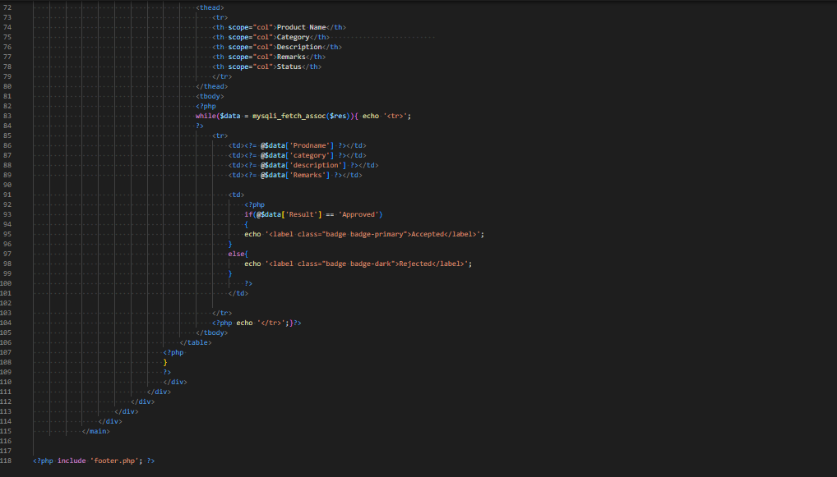

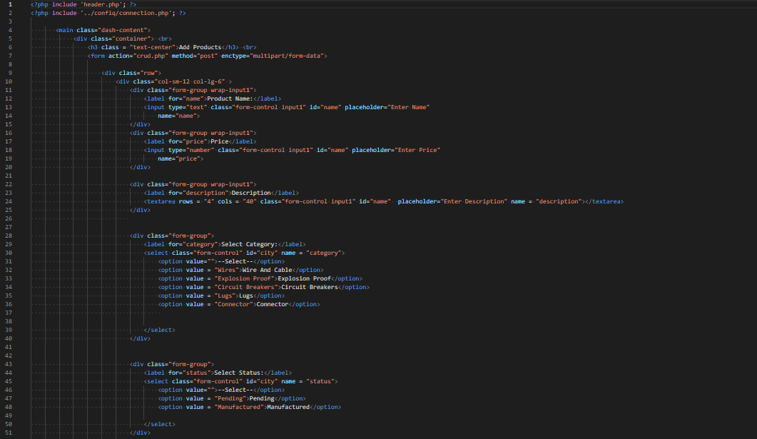

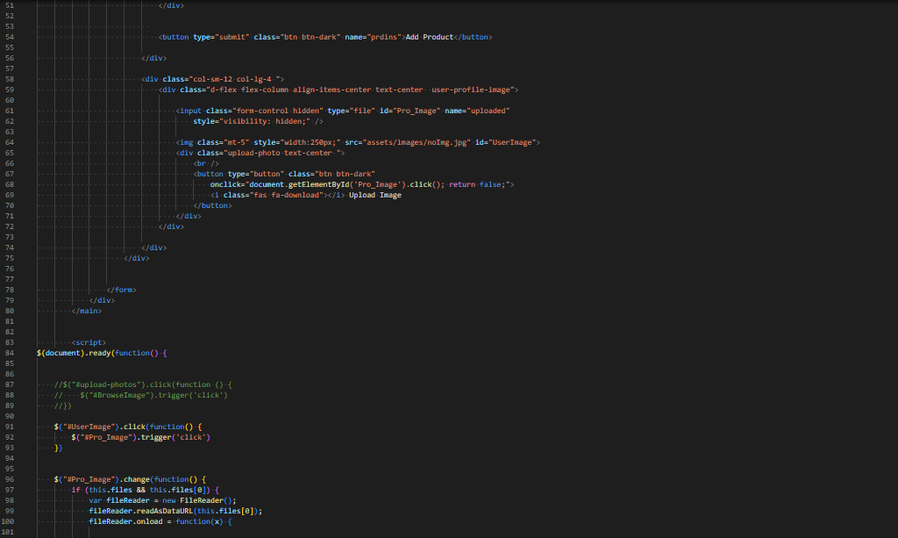

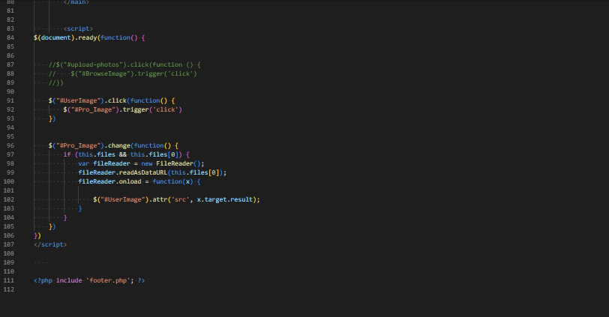

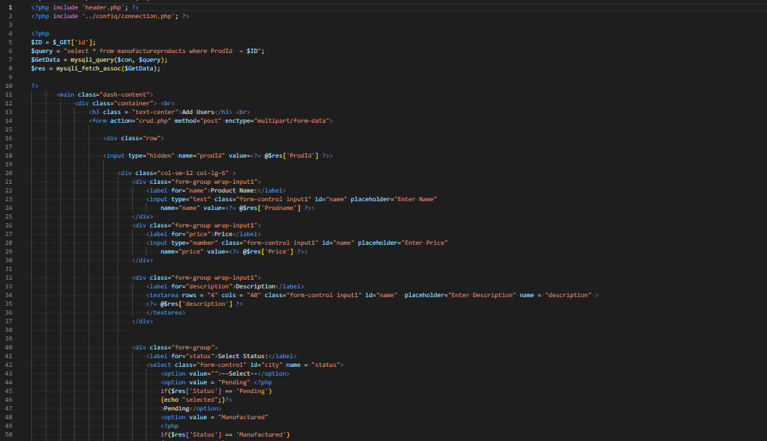

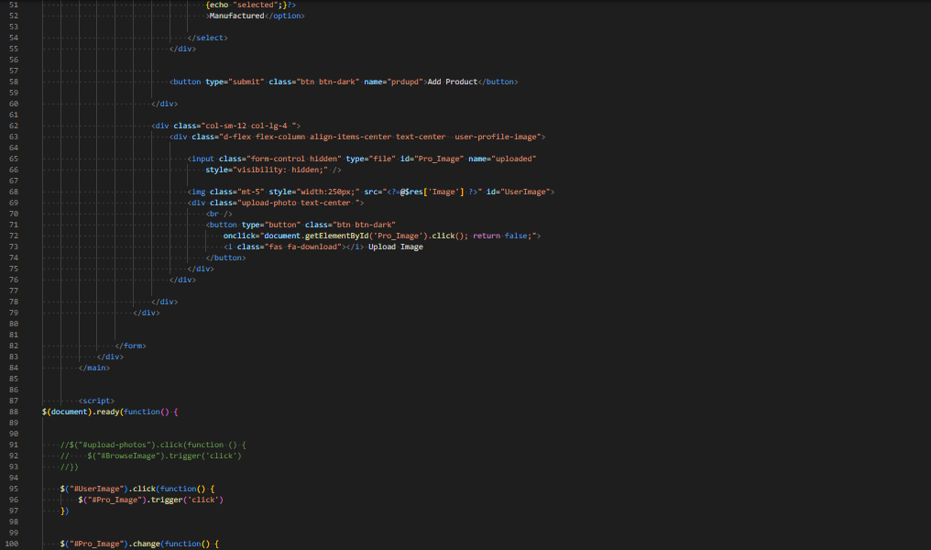

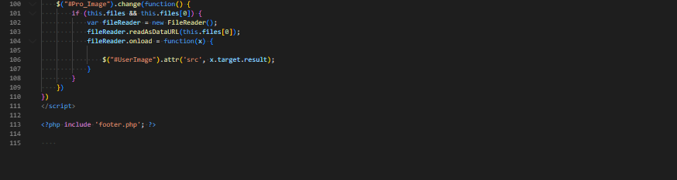

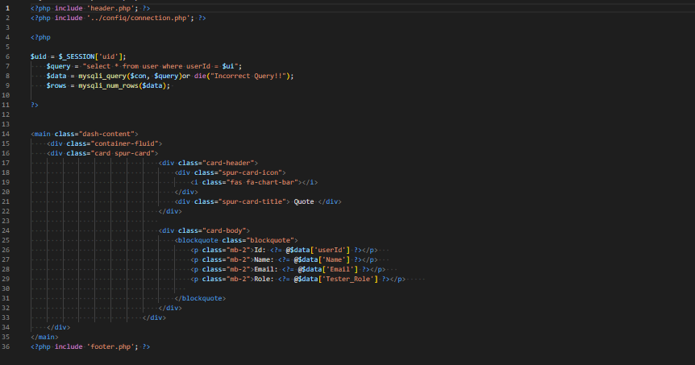

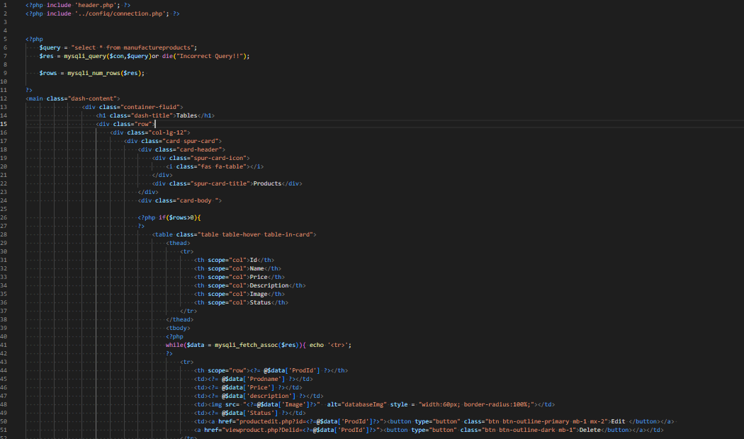

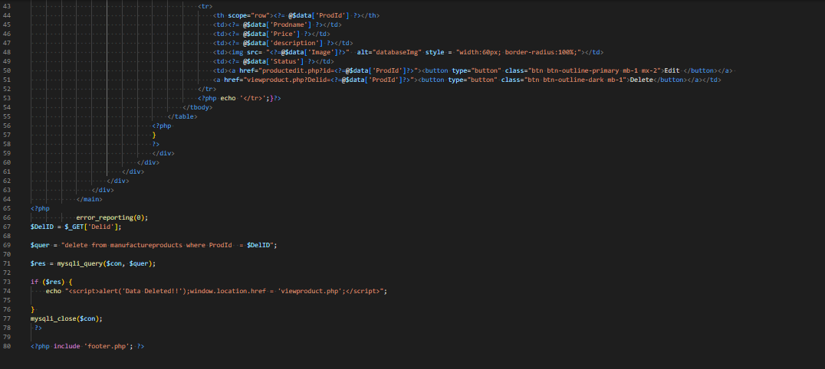

**COMPANY LAYOUT**

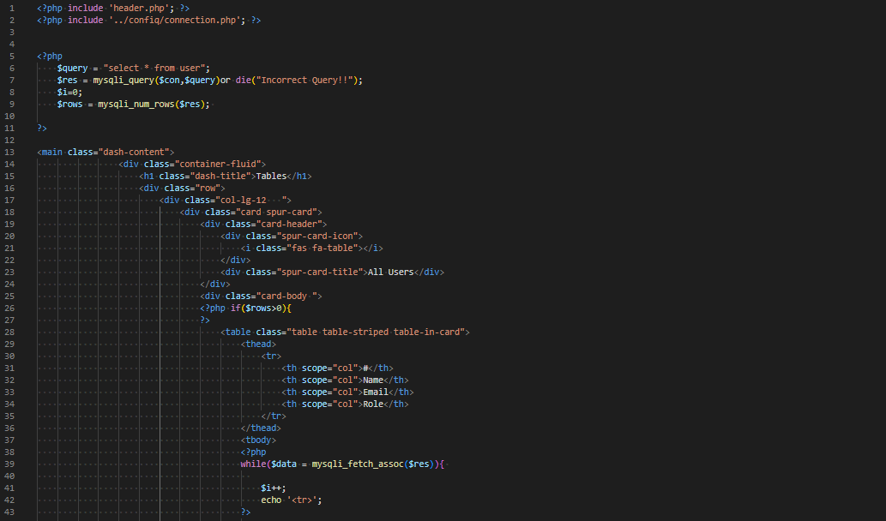

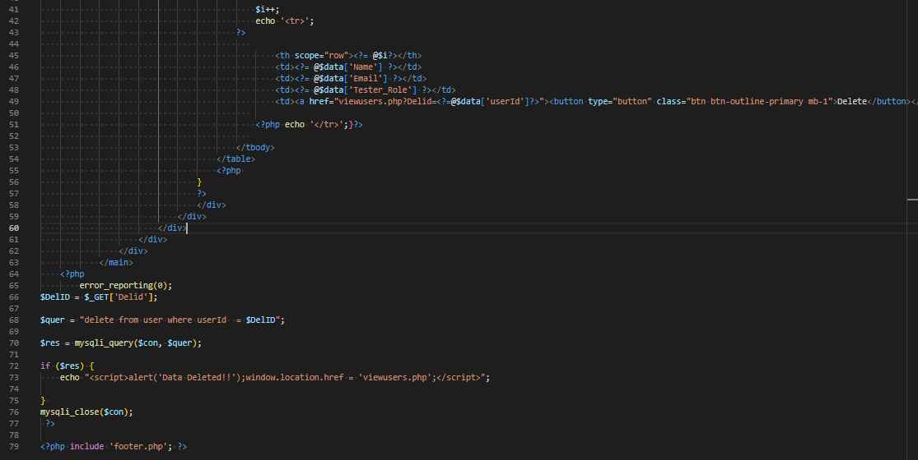

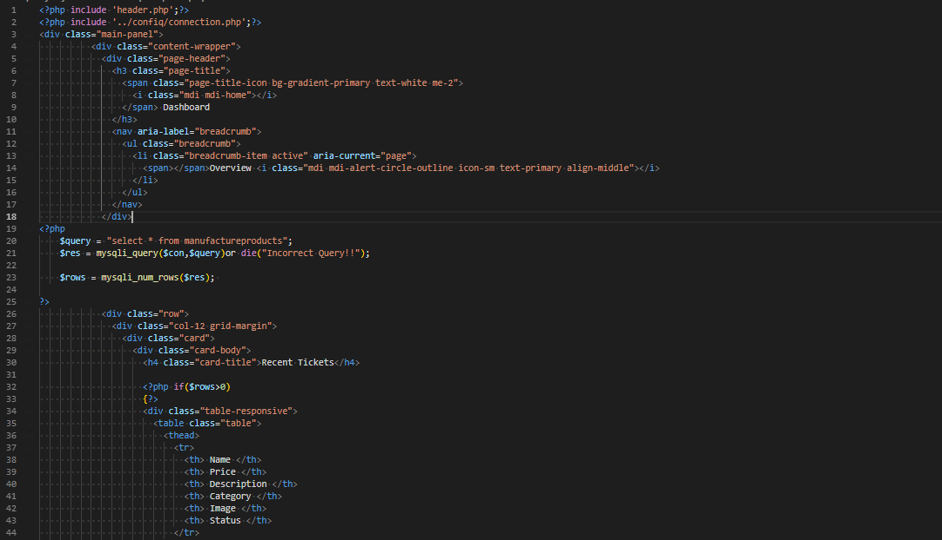

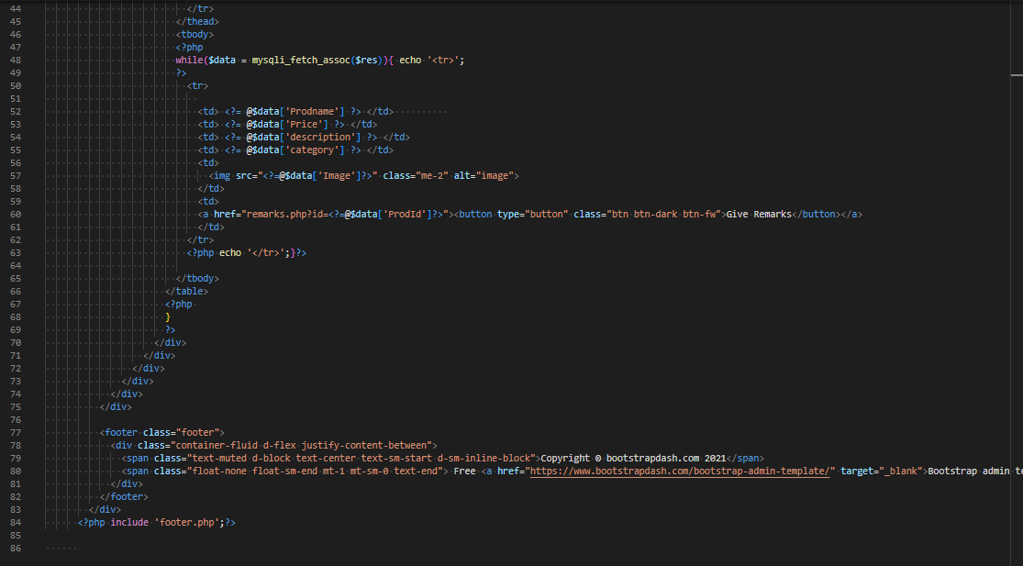

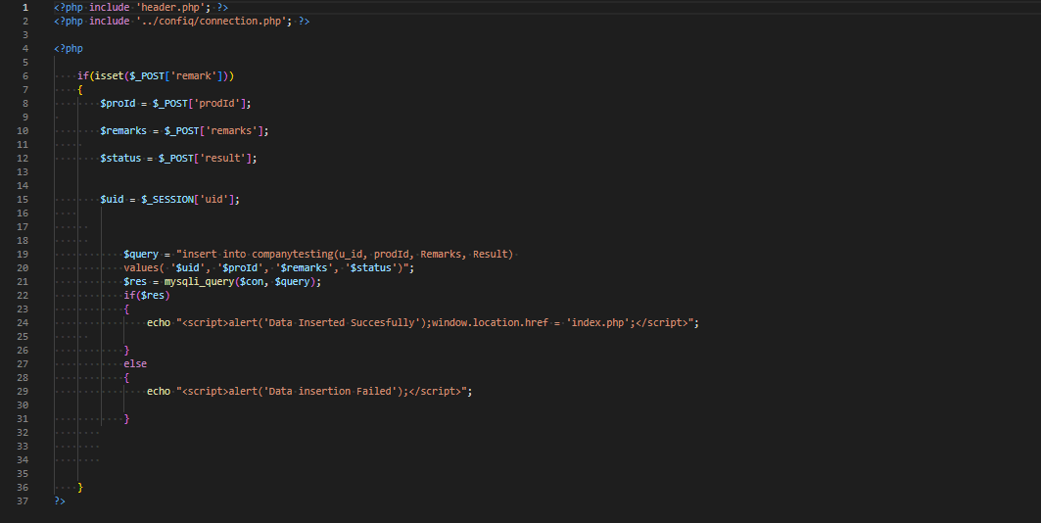

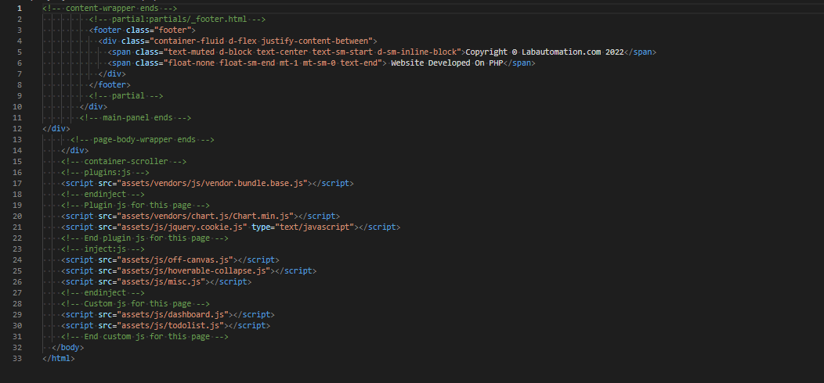

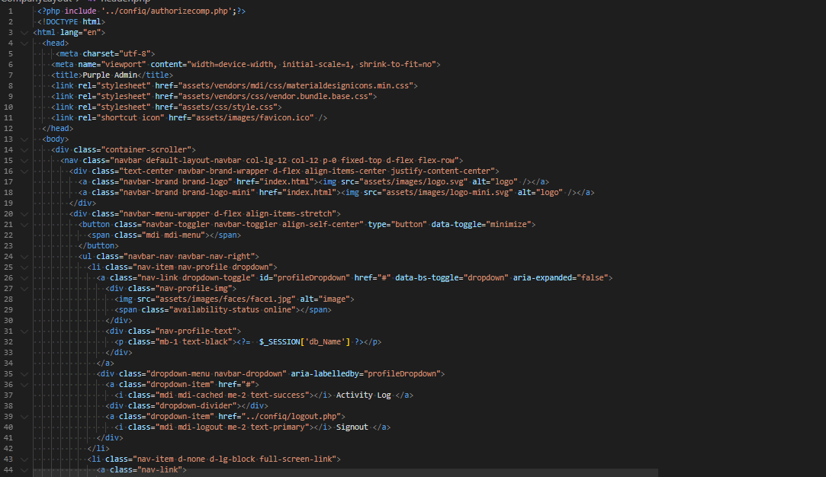

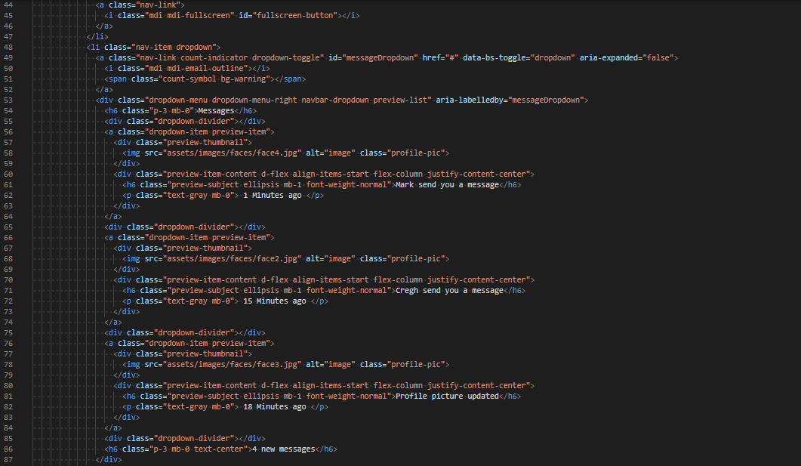

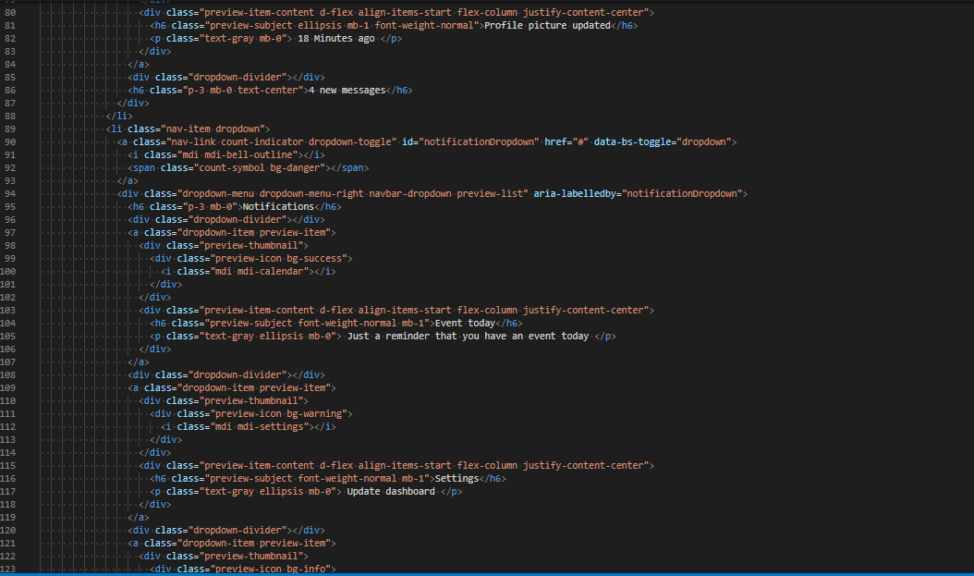

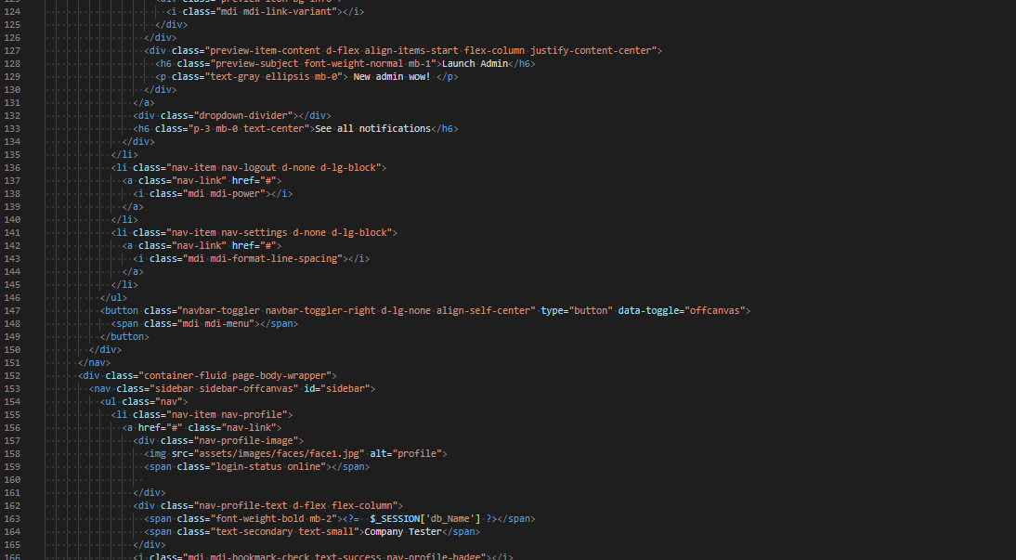

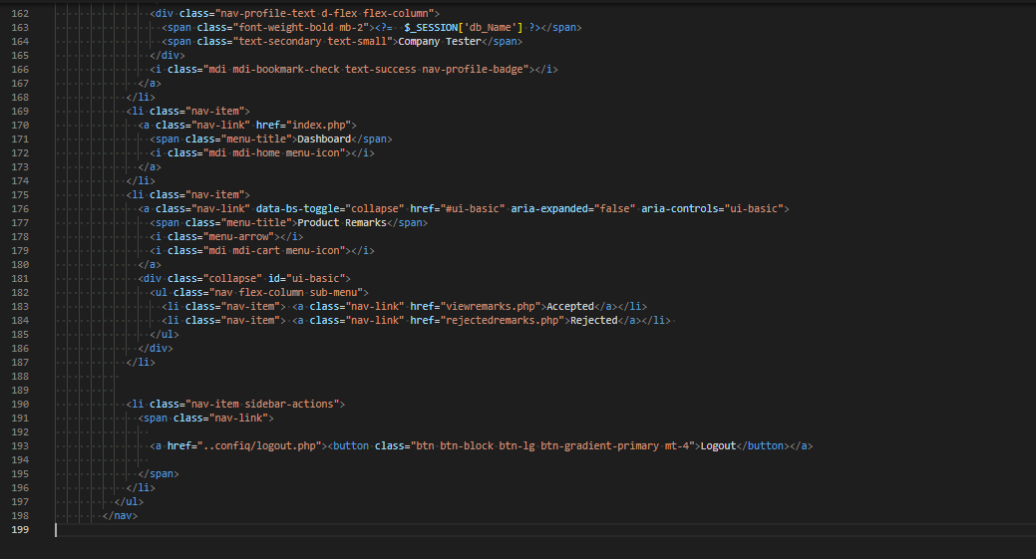

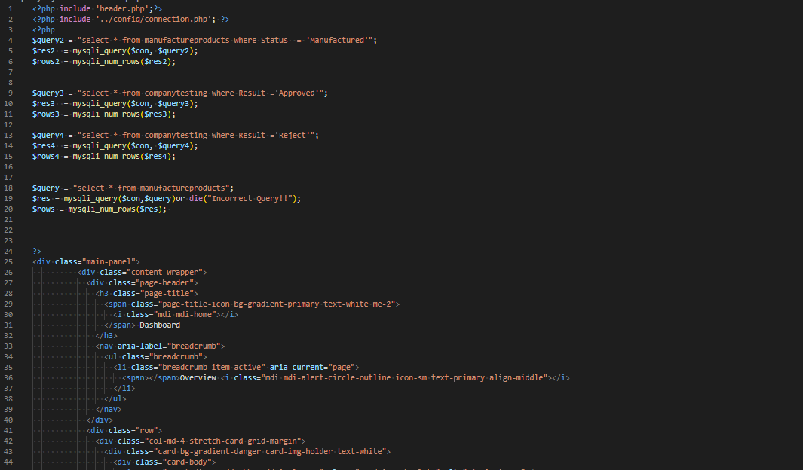

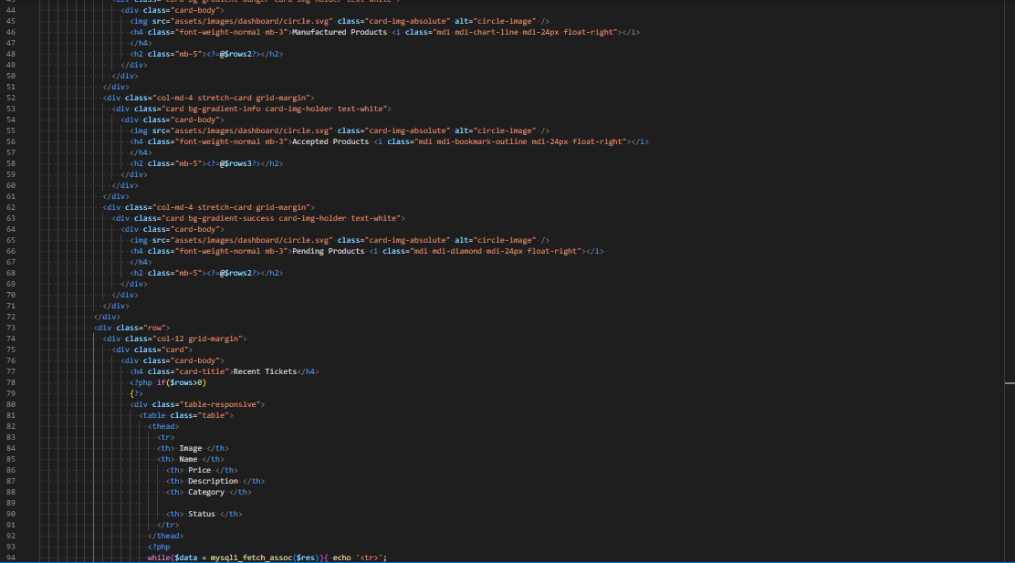

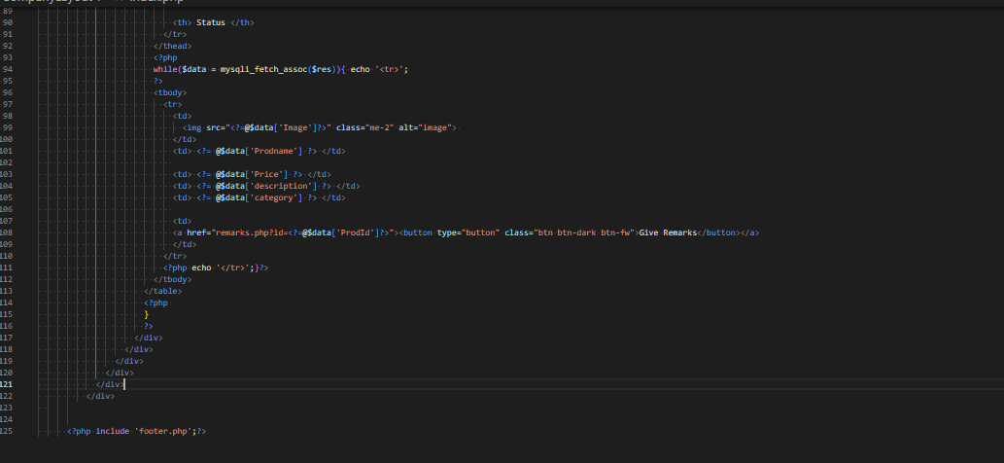

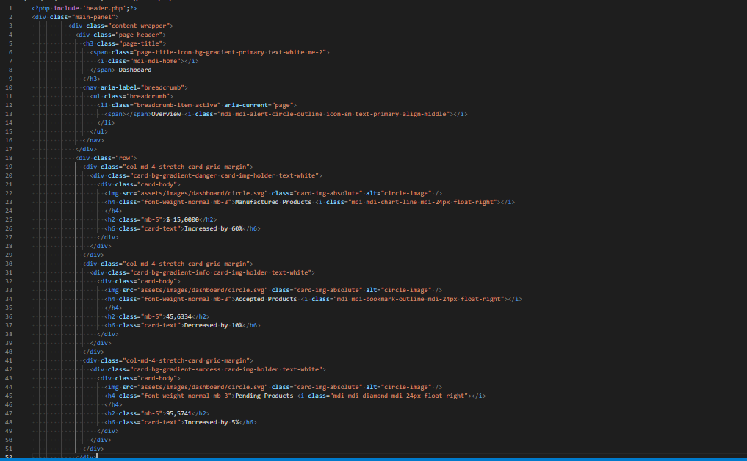

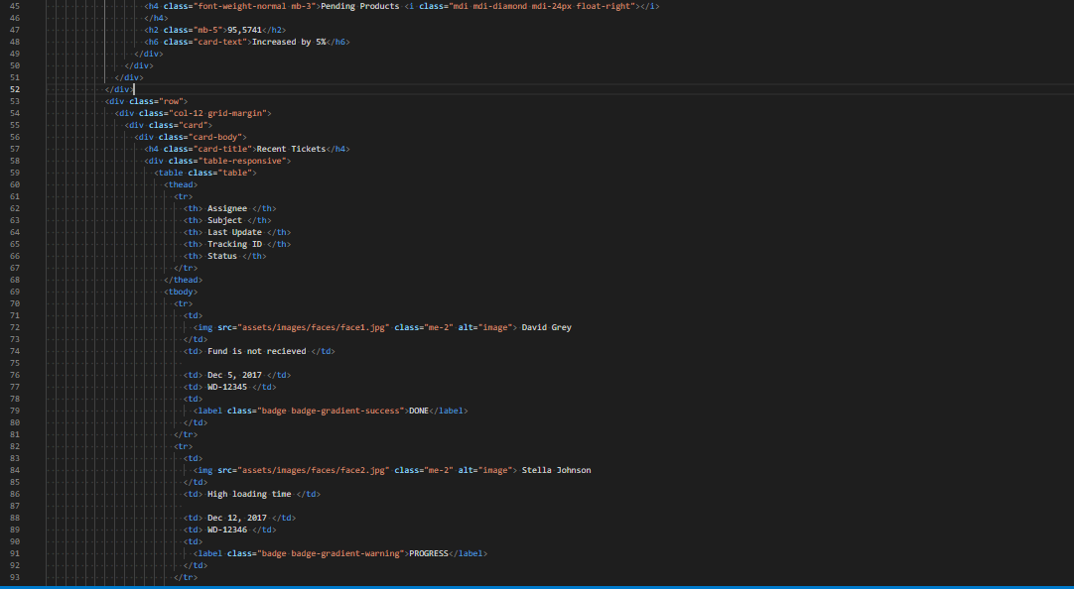

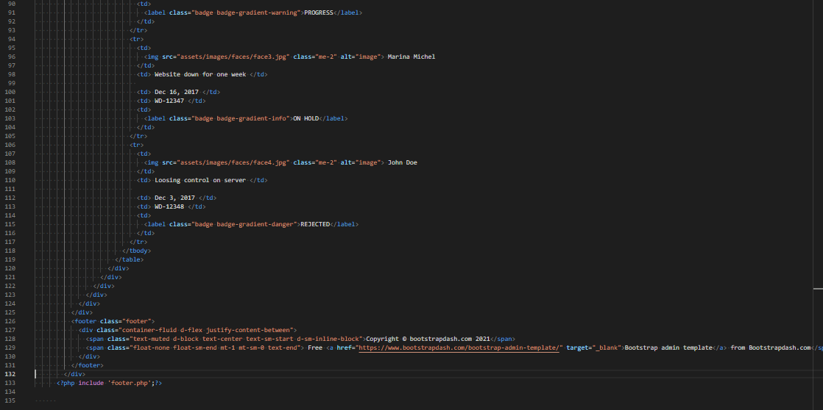

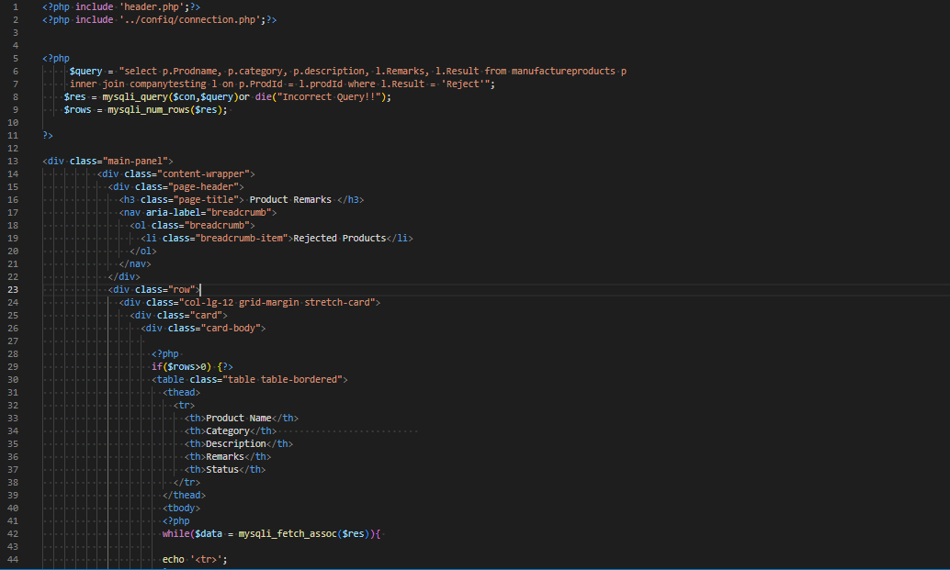

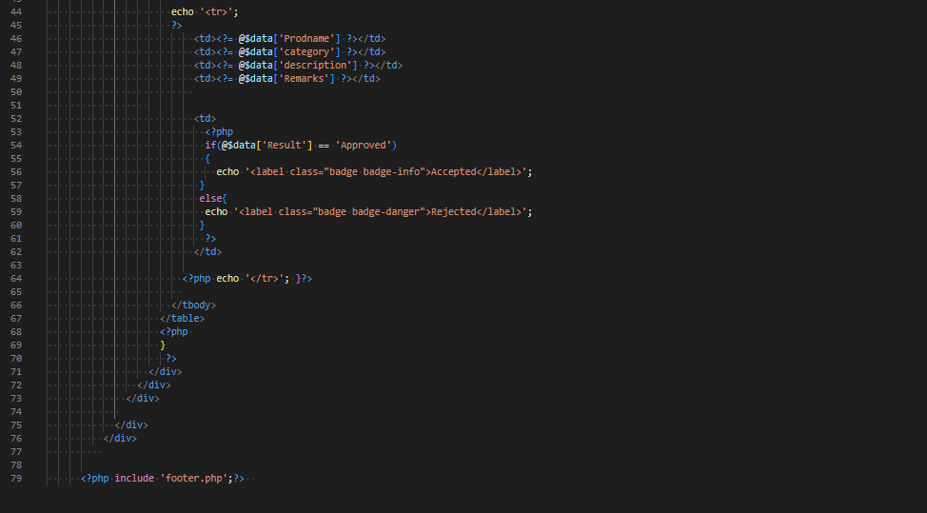

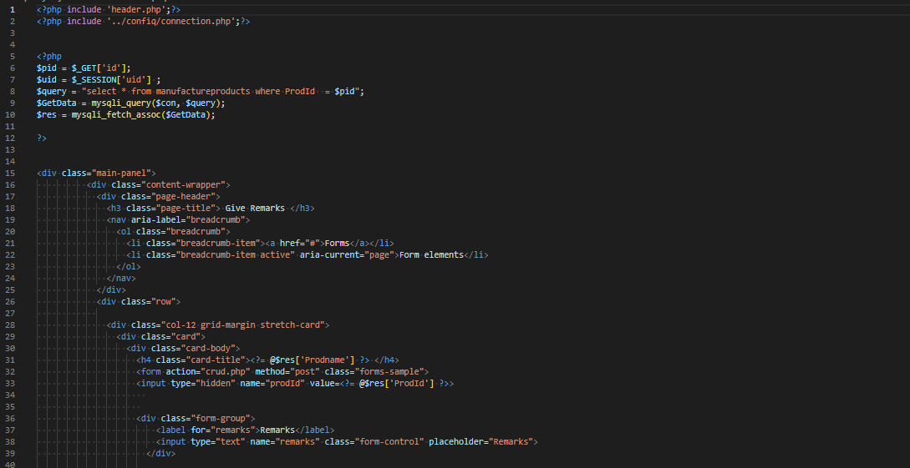

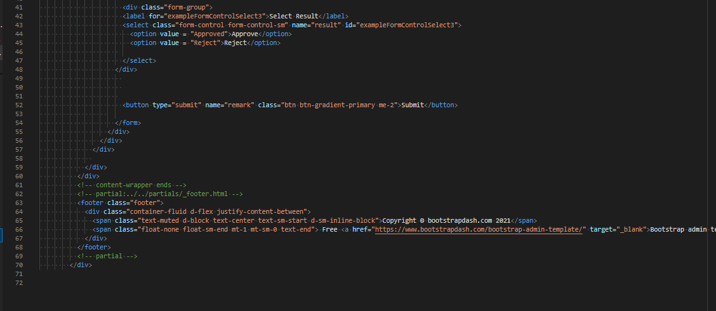

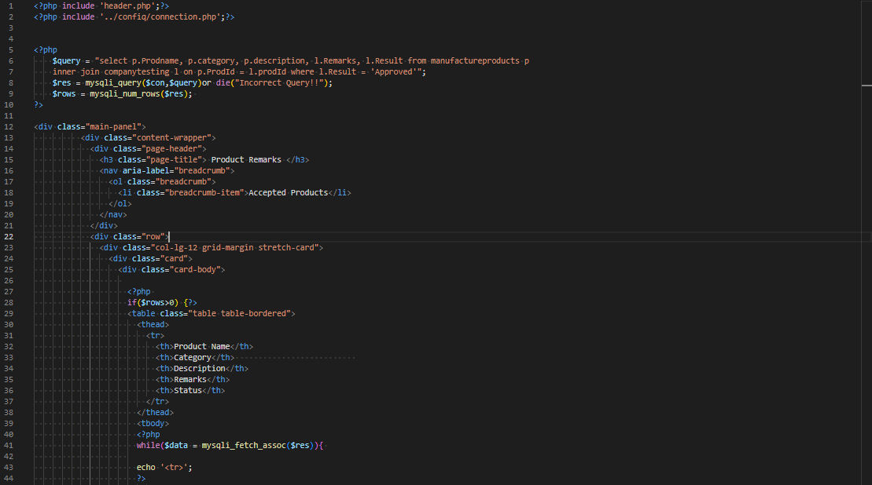

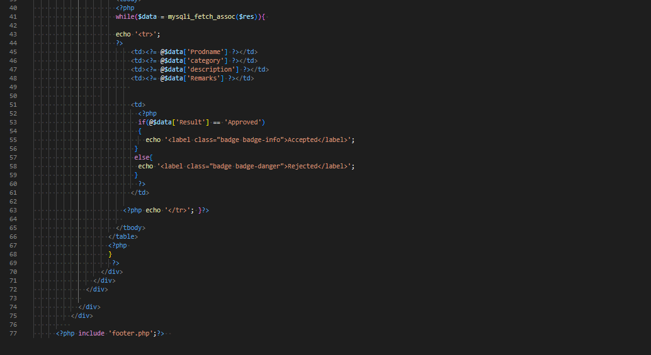

**CONFIG**

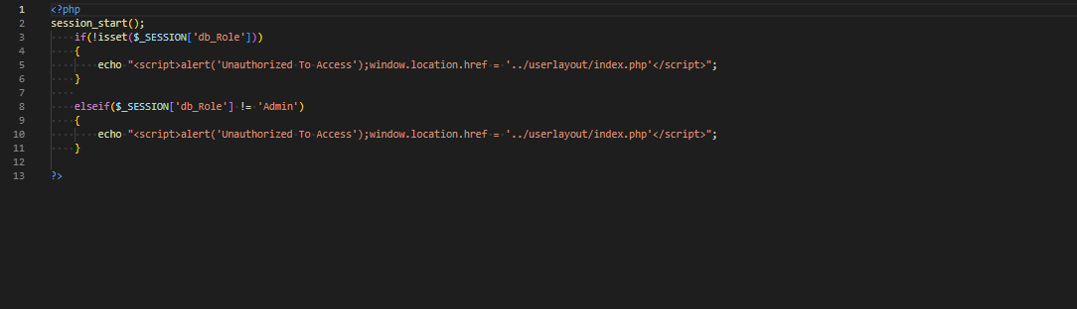

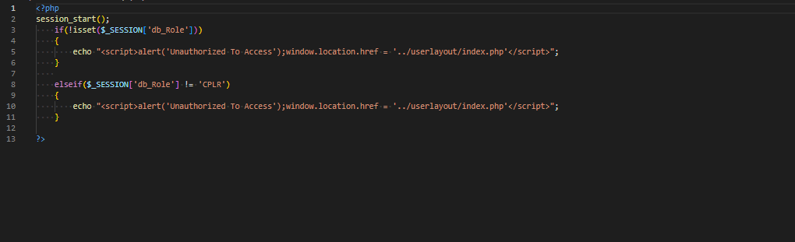

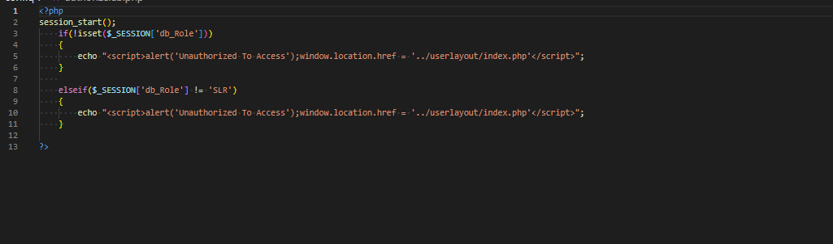

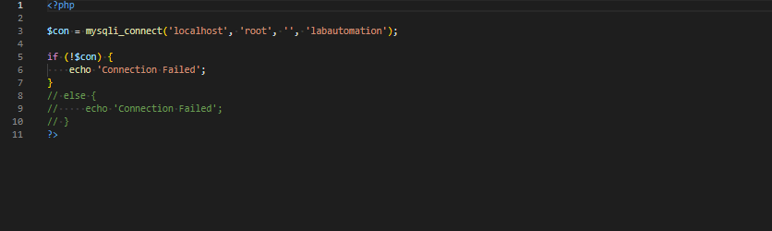

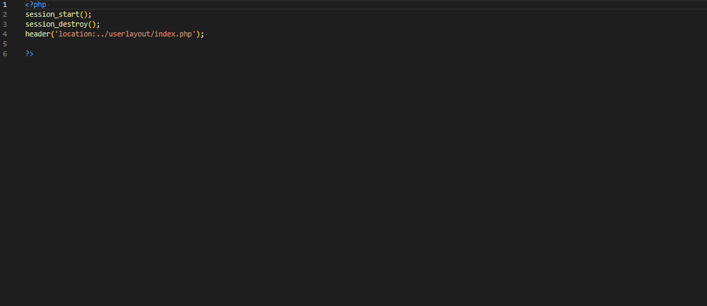

**LABORATARY LAYOUT**

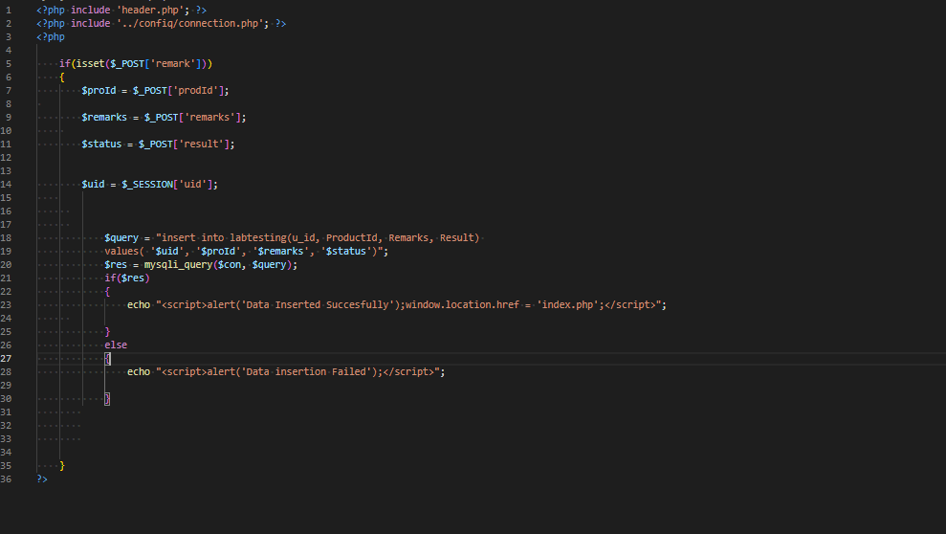

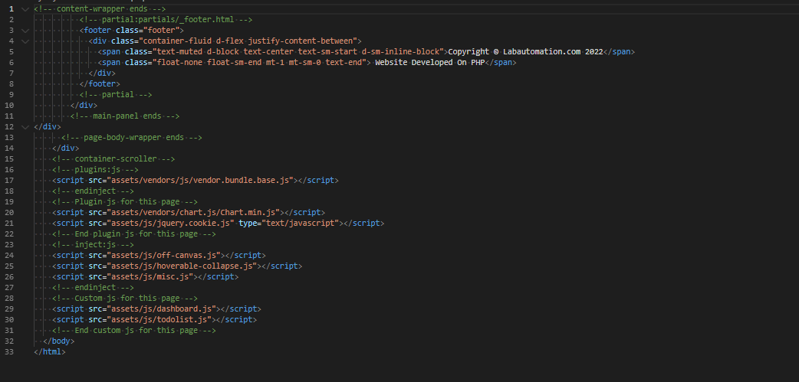

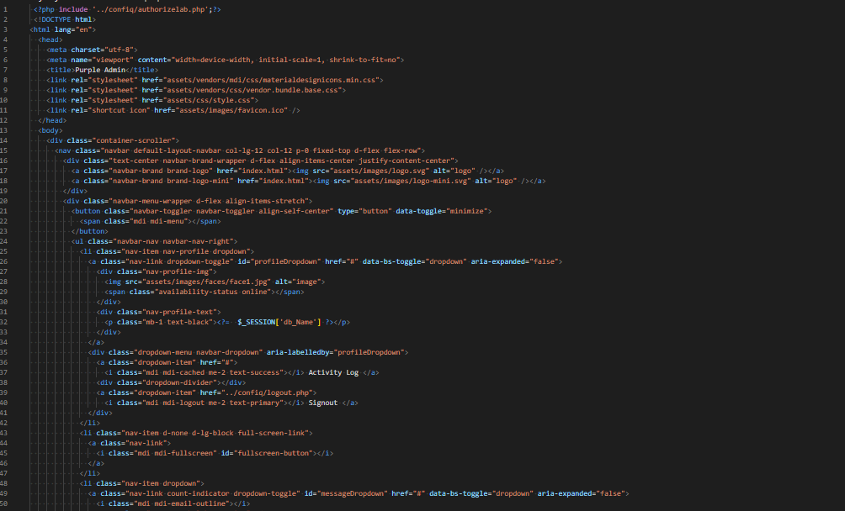

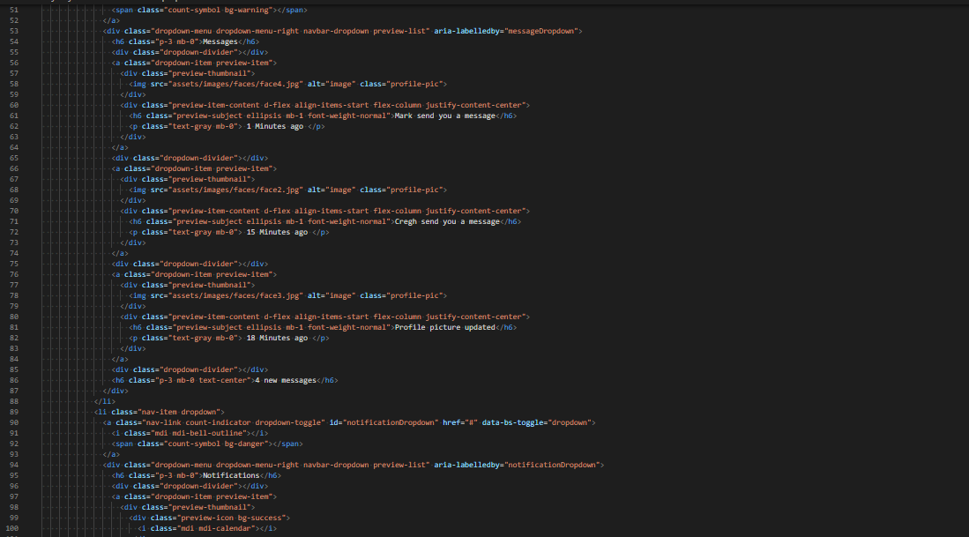

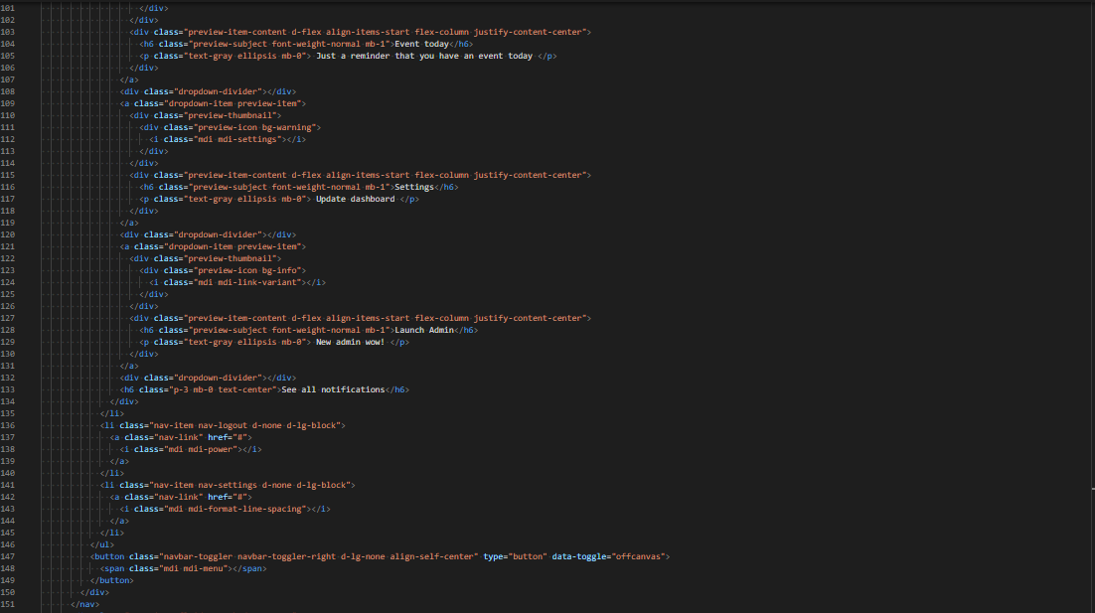

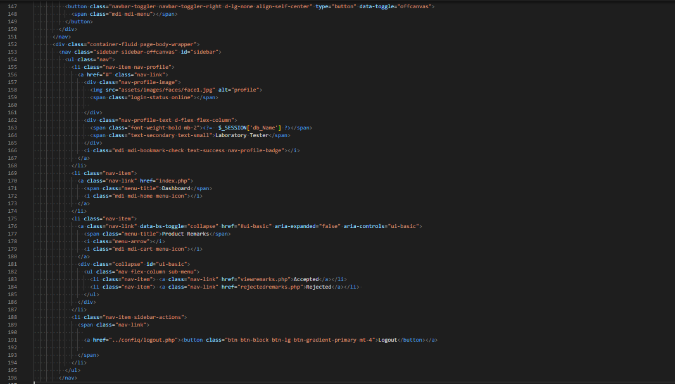

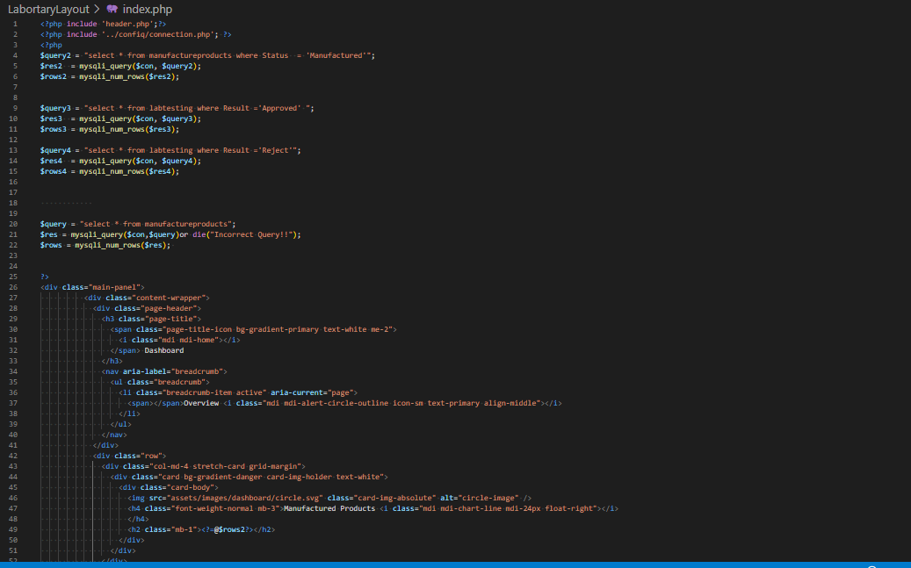

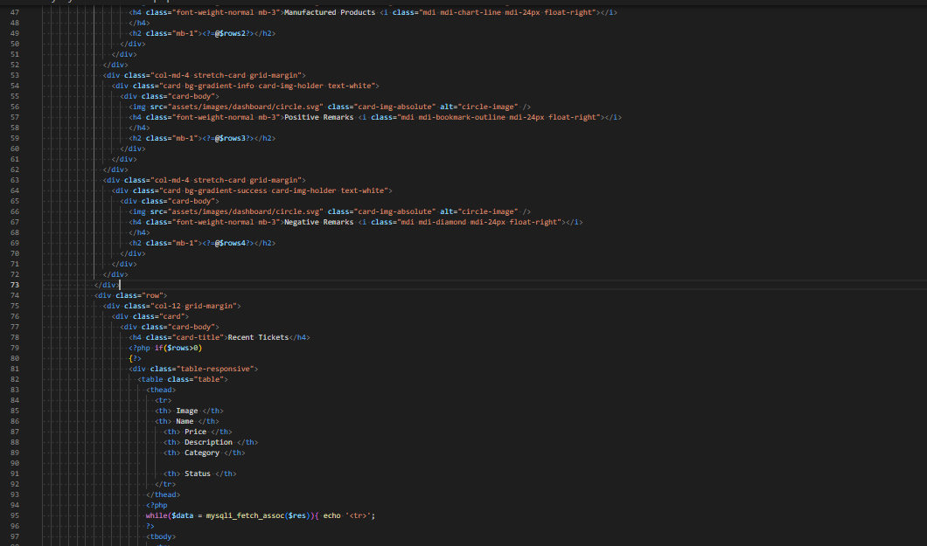

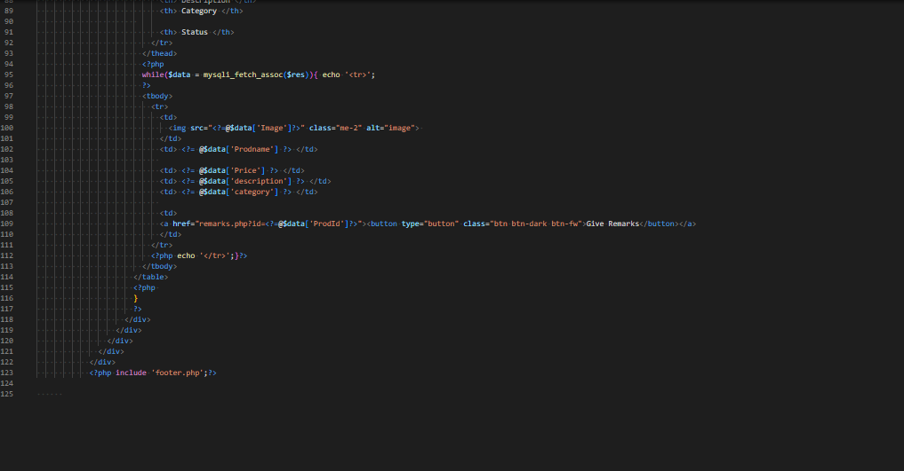

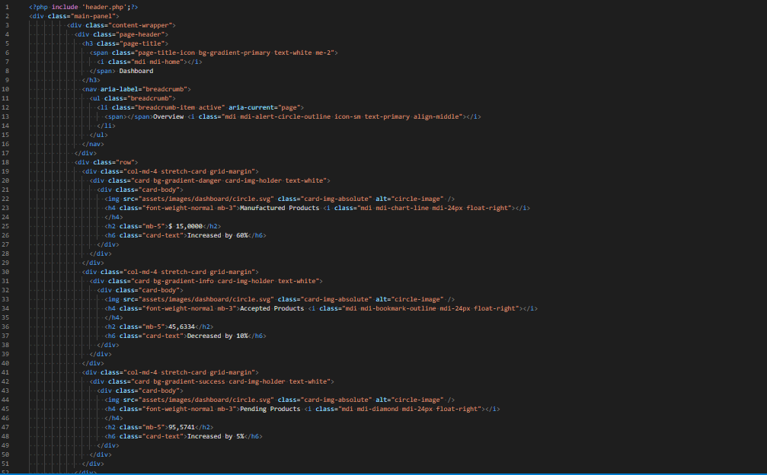

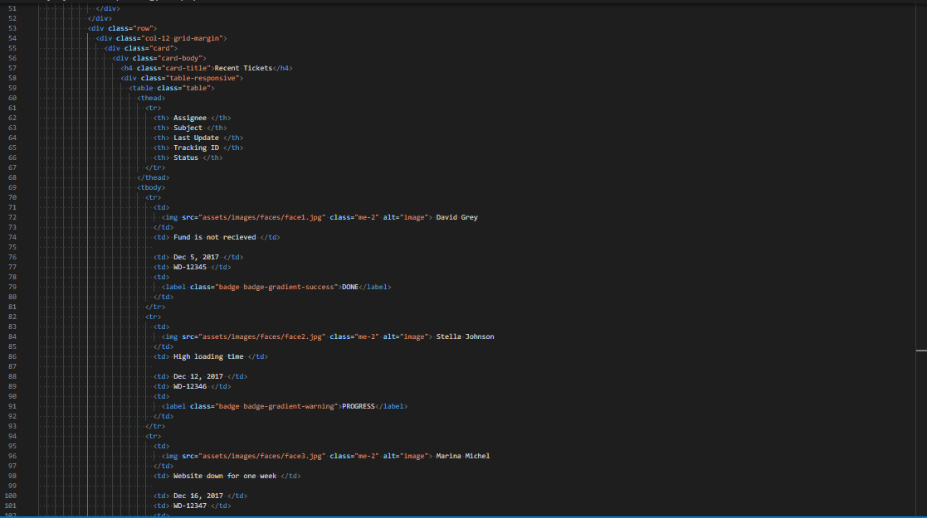

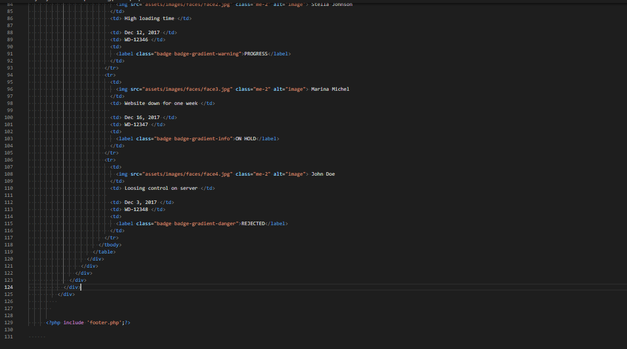

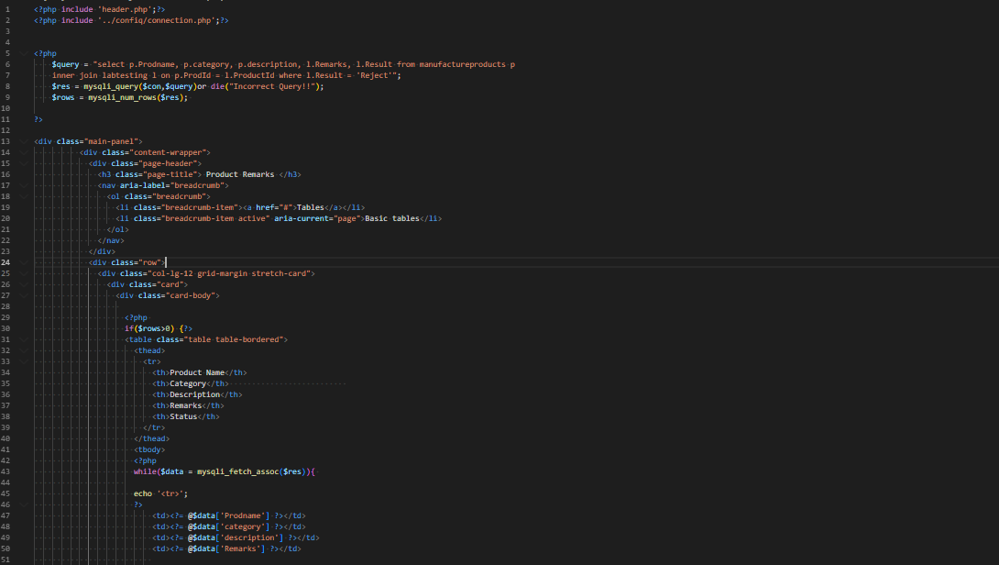

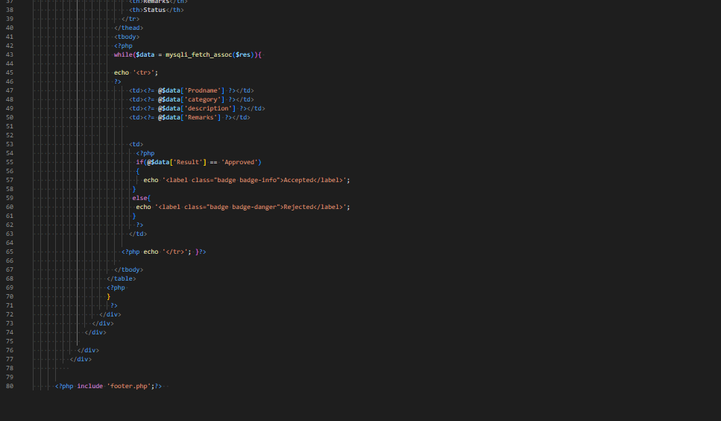

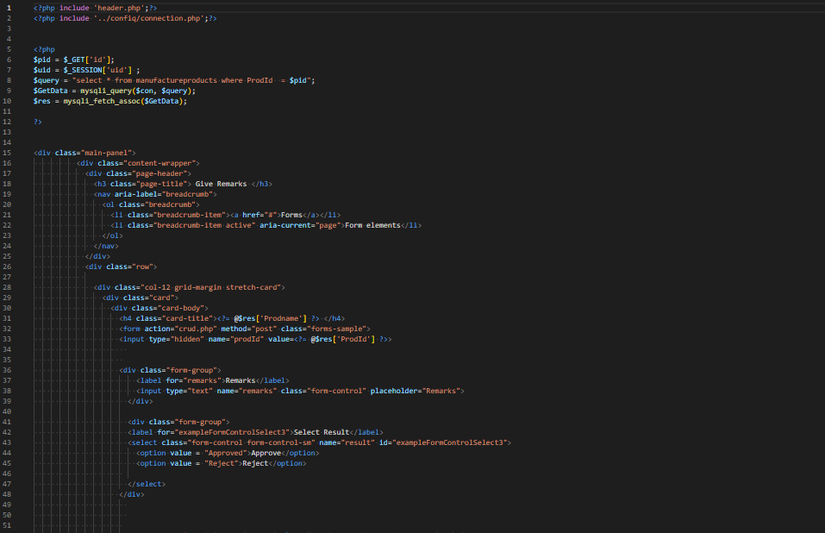

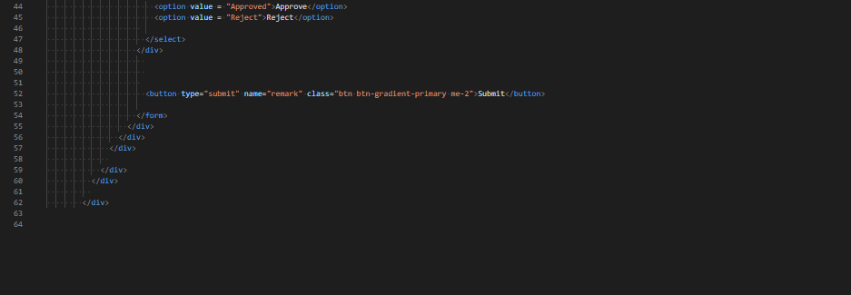

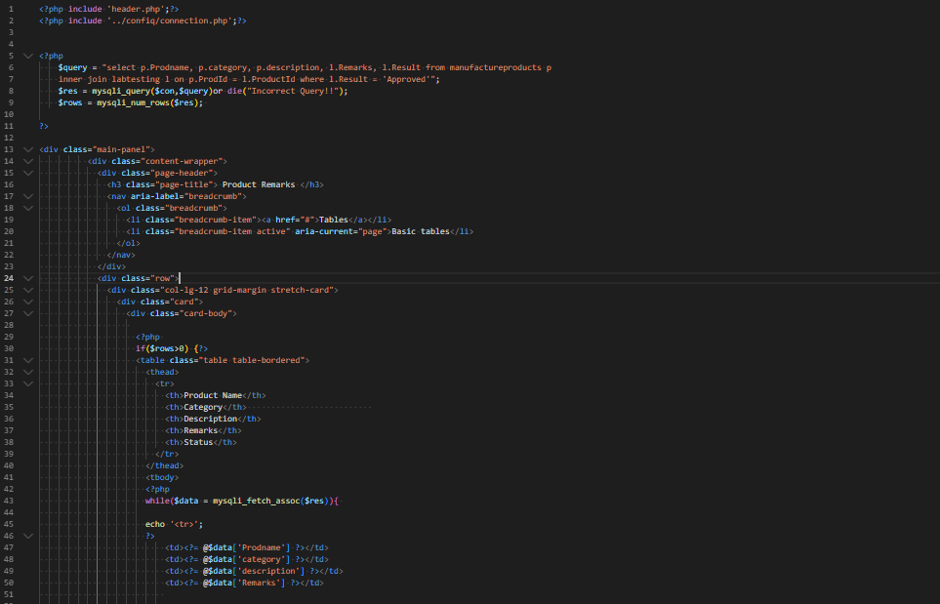

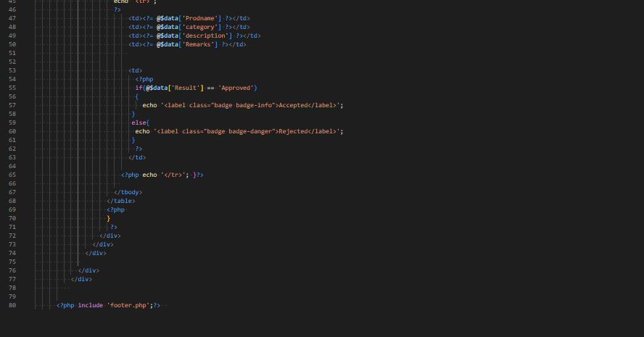

**USER LAYOUT**

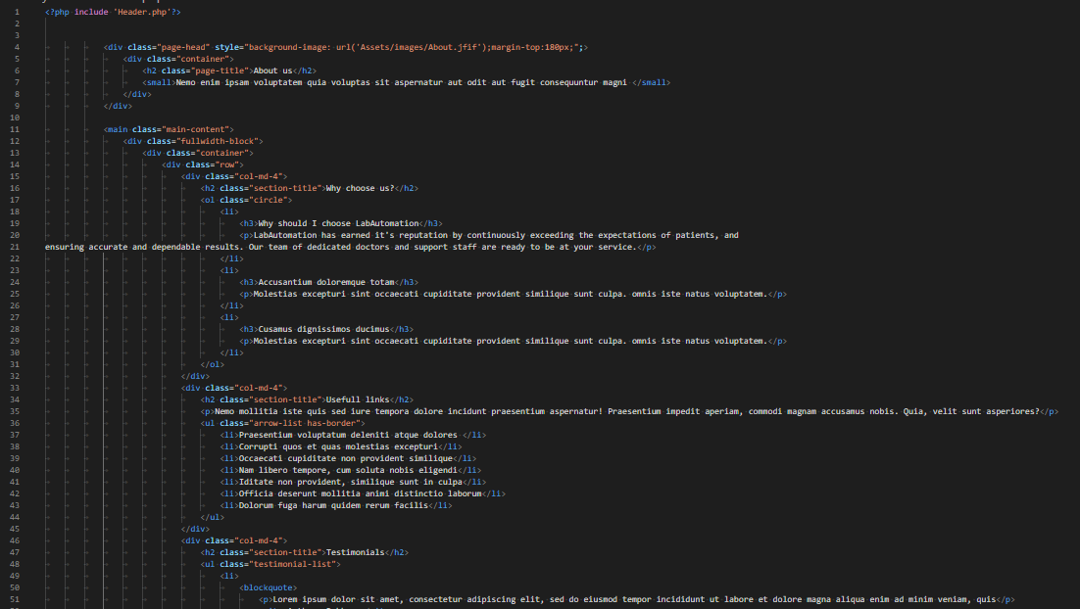

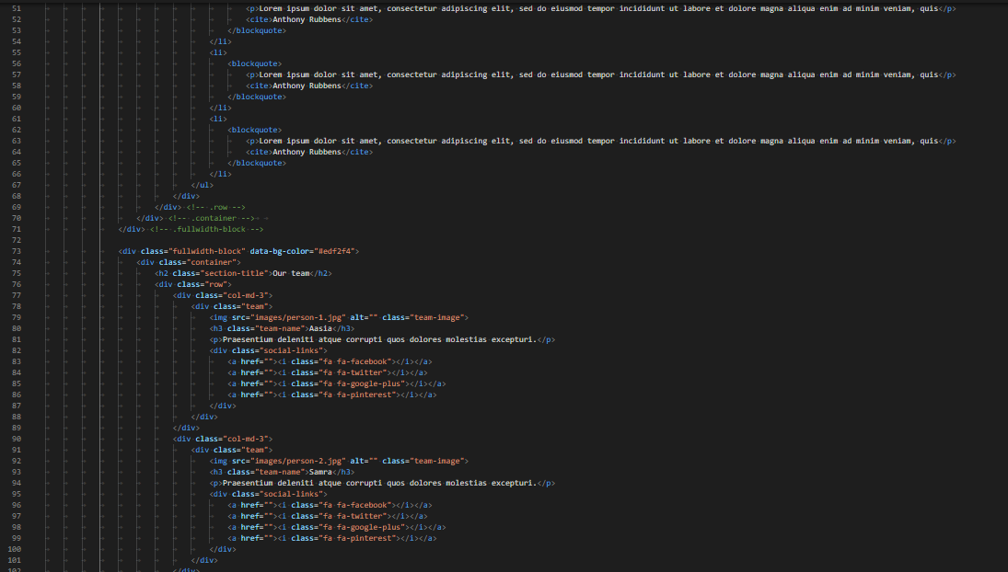

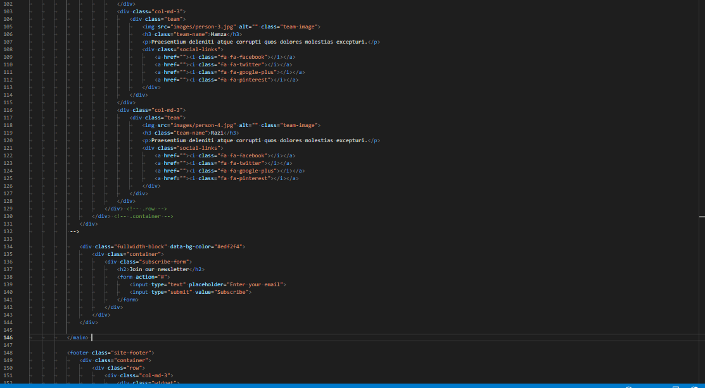

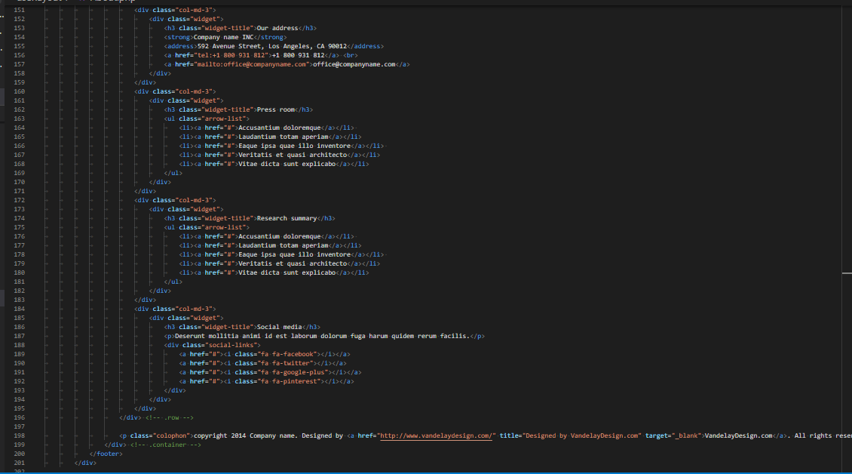

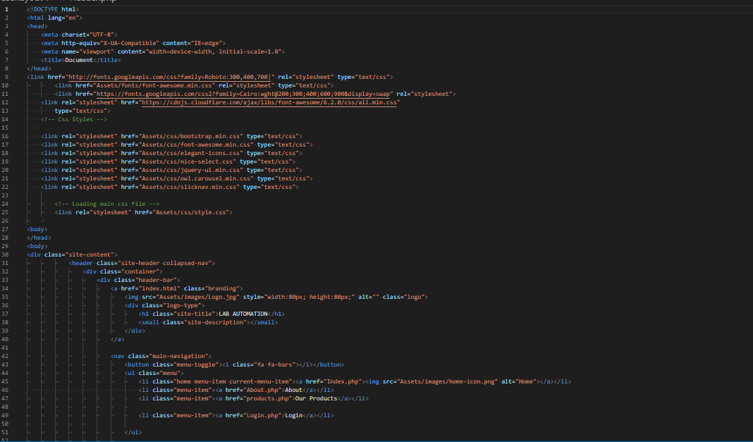

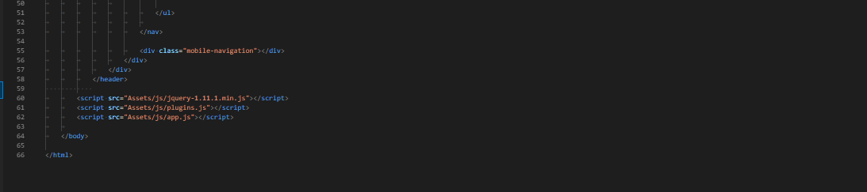

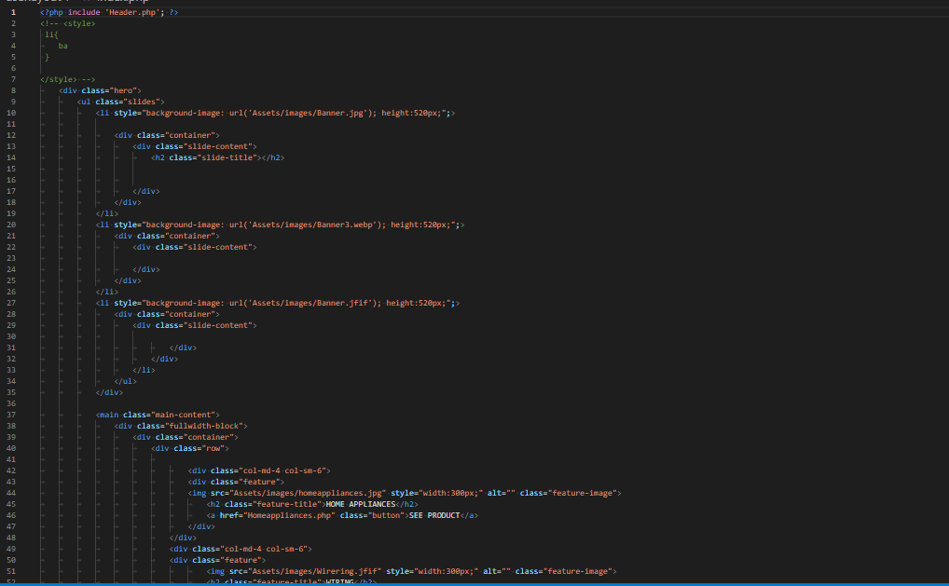

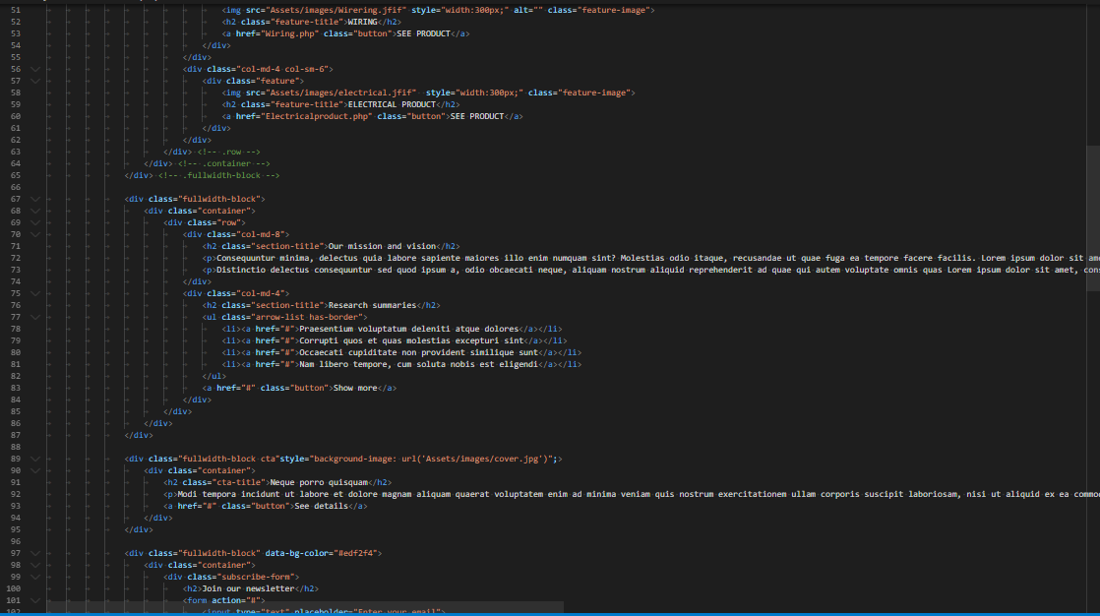

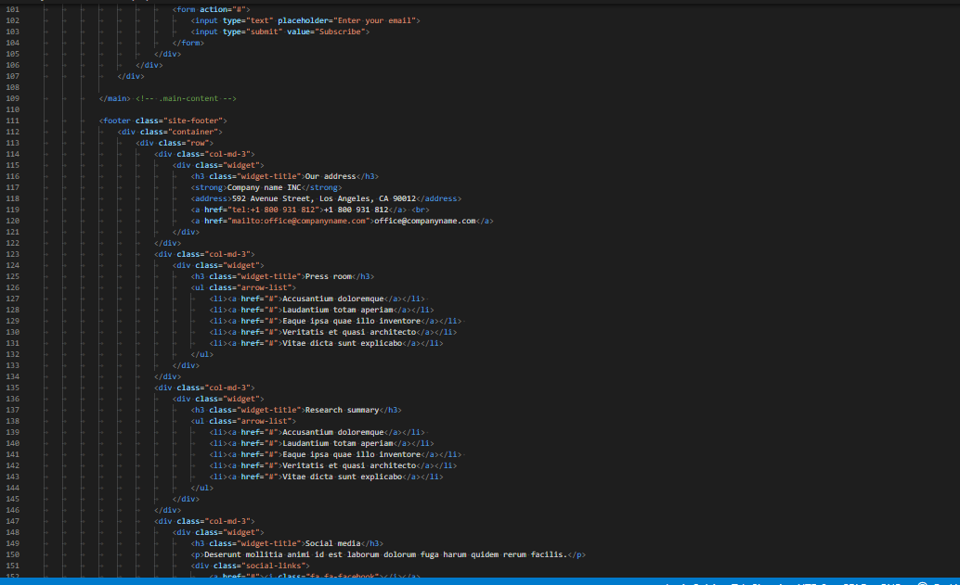

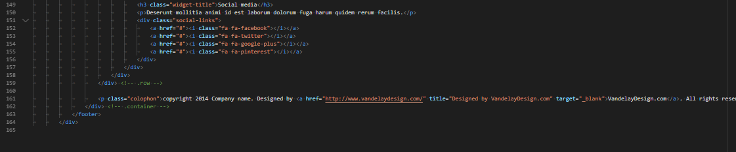

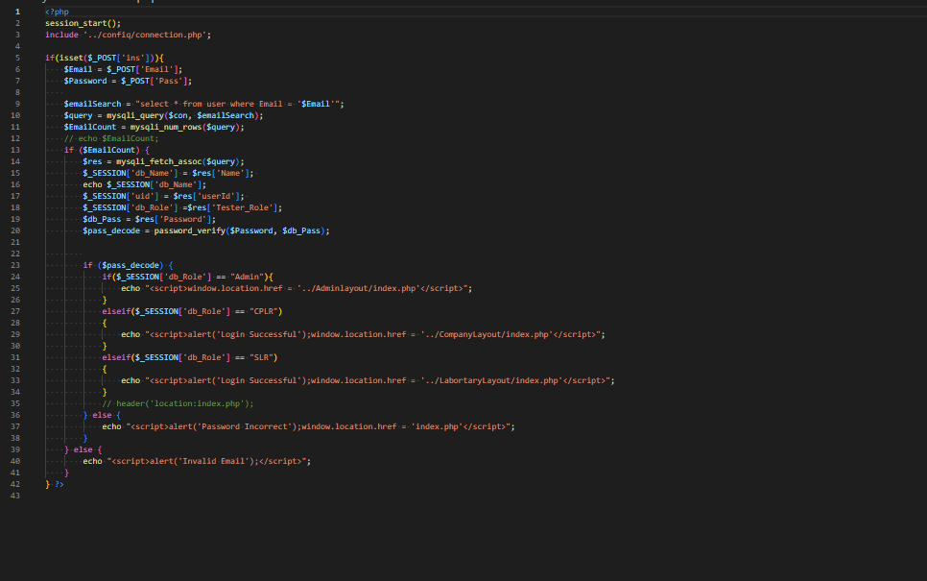

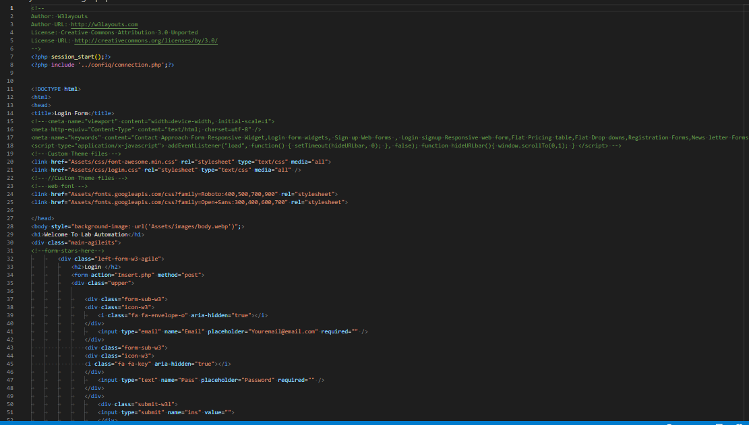

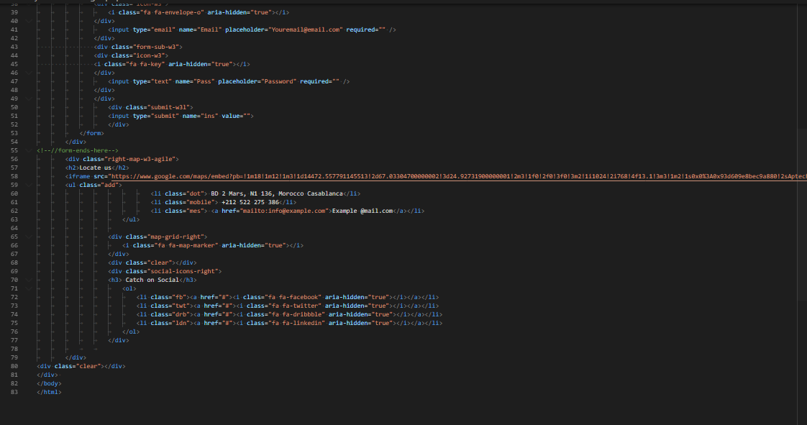

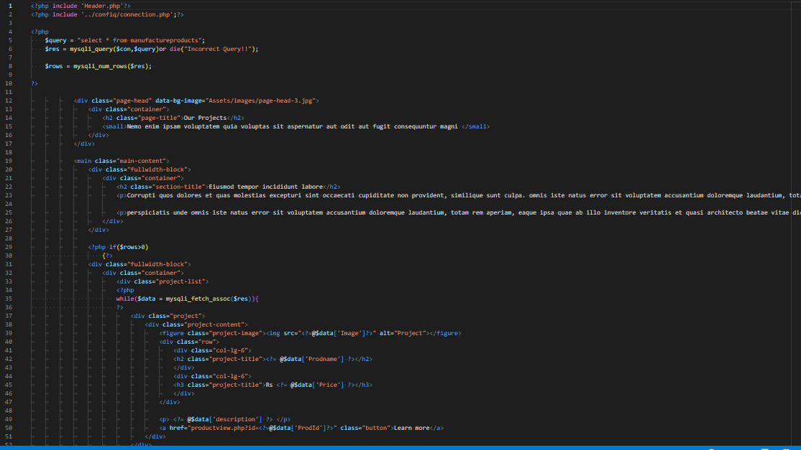

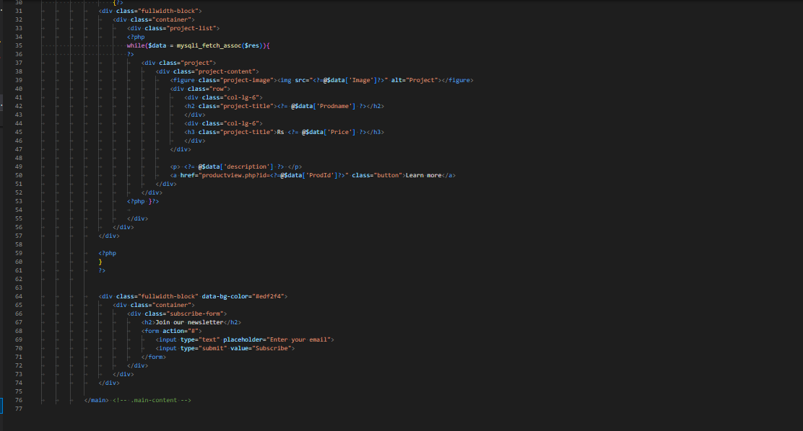

**SERIES 8:**

**Task sheet 1**

|  |  |  |  |  |  |  |
| --- | --- | --- | --- | --- | --- | --- |
| PAGES NAME | | PROJECT NAME | DATE OF PREPARATION OF TASK | | | |
| S.NO | Task | LAB AUTOMATION | Actual | Actual | Team-mate | Status |
| Start Date | Days | Names |
| 1 | Home Page | 22/11/22 | 2 | Aasia | Complete |
| 2 | About/Service Page | 24/11/22 | 2 | Aasia | Complete |
| 3 | Service Page | 26/11/22 | 2 | Hamza | Complete |
| 4 | Contact Page | 28/11/22 | 2 | Razi | Complete |
| 5 | Login/Logout | 30/11/22 | 2 | Hamza | Complete |

**Task sheet 2**

|  |  |  |  |  |  |  |
| --- | --- | --- | --- | --- | --- | --- |
| PAGES NAME | | PROJECT NAME | DATE OF PREPARATION OF TASK | | | |
| S.NO | Task | LAB AUTOMATION | Actual | Actual | Team-mate | Status |
| Start Date | Days | Names |
| 1 | Admin Panel | 2/12/22 | 2 | Samra | Complete |
| 2 | Add Tester/ View Tester | 4/12/22 | 2 | Samra | Complete |
| 3 | Add Product/ View Product | 6/12/22 | 2 | Hamza | Complete |
| 4 | Company Dashboard | 8/12/22 | 2 | Aasia | Complete |
| 5  6 | Product Testing  View Testing | 10/12/22  12/12/22 | 2  2 | Samra  Razi | Complete  Complete |

**Task sheet 3**

|  |  |  |  |  |  |  |
| --- | --- | --- | --- | --- | --- | --- |
| PAGES NAME | | PROJECT NAME | DATE OF PREPARATION OF TASK | | | |
| S.NO | Task | LAB AUTOMATION | Actual | Actual | Team-mate | Status |
| Start Date | Days | Names |
| 1 | Laboratory Dashboard | 14/12/22 | 2 | Aasia | Complete |
| 2 | Product Testing | 16/12/22 | 2 | Razi | Complete |
| 3 | Company Tester Form | 18/12/22 | 2 | Hamza | Complete |
| 4 | View Testing | 20/12/22 | 2 | Hamza | Complete |
| 5 | E-Project | 22/12/22 | 2 | Samra | Complete |

**SUBMISSION CHECK LIST**

|  |  |  |  |
| --- | --- | --- | --- |
| **Serial no** | **List of items** | **Remarks** | **comments** |
| One | Do all pages linked together | YES |  |
| Two | Authorization | YES |  |
| Three | Cruds Operation | YES |  |
| Four | Data Base Connection | YES |  |
| Five | Feedback Form Include | YES |  |
| Six | Project Zip File | YES |  |